LAB MANUAL OF

ALGORITHMS ANALYSIS AND DESIGN LAB

ETCS 351



Maharaja Agrasen Institute of Technology, PSP area, Sector – 22, Rohini, New Delhi – 110085
( Affiliated to Guru Gobind Singh Indraprastha University, New Delhi )

MAHARAJA AGRASEN INSTITUTE OF TECHNOLOGY

VISION
To nurture young minds in a learning environment of high academic value and imbibe spiritual and ethical values with technological and management competence.
MISSION
The Institute shall endeavor to incorporate the following basic missions in the teaching methodology:
Engineering Hardware – Software Symbiosis
Practical exercises in all Engineering and Management disciplines shall be carried out by Hardware equipment as well as the related software enabling deeper understanding of basic concepts and encouraging inquisitive nature.
Life – Long Learning
The Institute strives to match technological advancements and encourage students to keep updating their knowledge for enhancing their skills and inculcating their habit of continuous learning.
Liberalization and Globalization
The Institute endeavors to enhance technical and management skills of students so that they are intellectually capable and competent professionals with Industrial Aptitude to face the challenges of globalization.
Diversification
The Engineering, Technology and Management disciplines have diverse fields of studies with different attributes. The aim is to create a synergy of the above attributes by encouraging analytical thinking.
Digitization of Learning Processes
The Institute provides seamless opportunities for innovative learning in all Engineering and Management disciplines through digitization of learning processes using analysis, synthesis, simulation, graphics, tutorials and related tools to create a platform for multi-disciplinary approach.
Entrepreneurship
The Institute strives to develop potential Engineers and Managers by enhancing their skills and research capabilities so that they become successful entrepreneurs and responsible citizens.

MAHARAJA AGRASEN INSTITUTE OF TECHNOLOGY

COMPUTER SCIENCE & ENGINEERING DEPARTMENT
VISION
To Produce “Critical thinkers of Innovative Technology”
MISSION
To provide an excellent learning environment across the computer science discipline to inculcate professional behavior, strong ethical values, innovative research capabilities and leadership abilities which enable them to become successful entrepreneurs in this globalized world.

- To nurture an excellent learning environment that helps students to enhance their problem solving skills and to prepare students to be lifelong learners by offering a solid theoretical foundation with applied computing experiences and educating them about their professional, and ethical responsibilities.
- To establish Industry-Institute Interaction, making students ready for the industrial environment and be successful in their professional lives.
- To promote research activities in the emerging areas of technology convergence.
- To build engineers who can look into technical aspects of an engineering solution thereby setting a ground for producing successful entrepreneur.

INDEX OF THE CONTENTS
- Introduction to the lab
- Lab Requirements (details of H/W & S/W to be used)
- List of Experiments as per GGSIPU
- List of Experiments beyond the syllabus
- Format of the lab record to be prepared by the students.
- Marking scheme for the Practical Exam
- Instructions for each Lab Experiment
- Sample Viva – Questions

- Introduction to the Lab

Lab Objective
The main objective of this lab is to ensure that students can design efficient algorithms. The algorithm should be designed by analyzing its running time and space complexity. The emphasis is on choosing appropriate data structures and designing correct and efficient algorithms to operate on these data structures. It familiarizes students with some problems for which it is unknown whether there exist efficient algorithms.

Course Outcomes
At the end of the course, a student will be able to:

C351.1: Analyze the time and space complexity of incremental algorithms.
C351.2: Analyze and use the asymptotic behavior of Divide and Conquer approach in designing algorithms.
C351.3: Use concept of Dynamic Programming to develop the various algorithms.
C351.4: Development of algorithms based on Greedy Approach.
C351.5: Use different designing strategies to solve Graph Problems.
C351.6: Understand and develop the various String Matching Methods.

  - LAB REQUIREMENTS

Hardware Detail | Intel i3/C2D Processor/2 GB RAM/500GB HDD/MB/Lan Card/  Key Board/ Mouse/CD Drive/15” Color Monitor/ UPS 24 Nos
 | LaserJet Printer 1 No
Software Detail
CentOS/Fedora Linux

3. LIST OF EXPERIMENTS
(As prescribed by G.G.S.I.P.U)

Paper Code: ETCS-351 L T/P C Paper: Algorithms Analysis and Design Lab 0 2 1
List of Experiments:
- To implement following algorithm using array as a data structure and analyse its time complexity.
  - Merge sort
  - Quick sort
  - Bubble sort
  - Bucket sort
  - Radix sort
  - Shell sort
  - Selection sort
  - Heap sort

- To implement Linear search and Binary search and analyse its time complexity.
- To implement Matrix Multiplication and analyse its time complexity.
- To implement Longest Common Subsequence problem and analyse its time complexity.
- To implement Optimal Binary Search Tree problem and analyse its time complexity.
- To implement Huffman Coding and analyse its time complexity.
- To implement Dijkstra’s algorithm and analyse its time complexity.
- To implement Bellman Ford algorithm and analyse its time complexity.
- To implement naïve String Matching algorithm, Rabin Karp algorithm and Knuth Morris Pratt algorithm and analyse its time complexity.

NOTE:- At least 8 Experiments out of the list must be done in the semester.

  - LIST OF EXPERIMENTS
(Beyond the syllabus)

- To implement binomial coefficient computation and analyze its time complexity.
- To implement 0-1 Knapsack problem and analyze its time complexity.
- To implement Activity Selection Problem and analyze its time complexity.
- To implement Kruskal Algorithm and analyze its time complexity.
- To implement Prims Algorithm and analyze its time complexity.

- FORMAT OF THE LAB RECORD TO BE PREPARED BY THE STUDENTS

The front page of the lab record prepared by the students should have a cover page as displayed below.

ALGORITHM ANALYSIS AND DESIGN LAB
ETCS 351

Faculty name Student name
Roll No.:
Semester:

Font should be (12”, Times Roman)


Maharaja Agrasen Institute of Technology, PSP Area,
Sector – 22, Rohini, New Delhi – 110085
Font should be (18”, Times Roman)
Index

Exp. no | Experiment Name | Date of performance | Date of checking | Marks | Signature

- MARKING SCHEME FOR THE PRACTICAL EXAMS
There will be two practical exams in each semester.

- Internal Practical Exam
- External Practical Exam

INTERNAL PRACTICAL EXAM

It is taken by the respective faculty of the batch.

MARKING SCHEME FOR THIS EXAM IS:

Total Marks: 40

Division of 10 marks per practical is as follows:

Rubrics for Lab Assessment
Rubrics |  |  | 0 | 1 |  | 2 | 3
 |  |  | Missing | Inadequate |  | Needs  Improvement | Adequate
R1 | Is able to identify the problem to be solved and define the objectives of the experiment. |  | No mention is made of the problem to be  solved. | An attempt is made to identify the  be solved described confusing objectives relevant, contain conceptual objectives measurable. | problem to but it is  in a  manner, are not  objectives technical/ errors or are not | The problem to be solved is described but there are minor omissions or vague  details. Objectives are conceptually correct and measurable but may be incomplete in  scope or have  linguistic errors. | The problem to be solved is clearly  stated. Objectives are complete, specific,  concise, and  measurable. They are written using correct technical terminology and are free from linguistic errors.
R2 | Is able to desi reliable experiment solves problem. | gn a  that the | The experiment does not solve  the problem. | The experiment  attempts to solve the problem but due to the nature of the design the data will not lead to a reliable solution. |  | The experiment  attempts to solve the problem but due to the nature of the design there is a moderate chance the  data will not lead to a reliable solution. | The experiment  solves the problem  and has a high likelihood of  producing data that  will lead to a reliable solution.
R3 | Is able  communicate details of experimental procedure cl and completely. | to the an  early | Diagrams are missing and/or  experimental  procedure is missing or  extremely vague. | Diagrams are present but unclear and/or experimental procedure is present but important details are missing. |  | Diagrams and/or  experimental procedure are present  but with minor  omissions or vague  details. | Diagrams and/or  experimental procedure are clear and complete.
R4 | Is able to record  and represent  data in a  meaningful way. |  | Data are either  absent or  incomprehensible. | Some important data  are absent or  incomprehensible. |  | All important data are present, but recorded in a way that requires  some effort to  comprehend. | All important data are present, organized  and recorded clearly.
R5 | Is able to make a judgment about  the results of the experiment. |  | No discussion is presented about the results of the experiment . | A judgment is made  about the results, but it is not reasonable or coherent. |  | An acceptable  judgment is made  about the result, but  the reasoning is  flawed or incomplete. | An acceptable  judgment is  about the result, clear reasoning.  effects assumptions experimental uncertainties considered. | Made  with  The  of  and  are

Each experiment will be evaluated out of 10 marks. At the end of the semester average of 8 best performed practical will be considered as marks out of 40.

EXTERNAL PRACTICAL EXAM

It is taken by the concerned lecturer of the batch and by an external examiner. In this exam student needs to perform the experiment allotted at the time of the examination, a sheet will be given to the student in which some details asked by the examiner needs to be written and at the last viva will be taken by the external examiner.

MARKING SCHEME FOR THIS EXAM IS:

Total Marks: 60

Division of 60 marks is as follows

  - Sheet filled by the student: 20

  - Viva Voice: 15

  - Experiment performance: 15

  - File submitted: 10

NOTE:

- Internal marks + External marks = Total marks given to the students
(40 marks) (60 marks) (100 marks)

- Experiments given to perform can be from any section of the lab.

- Instructions for each Lab Experiment

Experiment 1
Aim: To implement following algorithm using array as a data structure and analyse its time complexity.
    - Merge sort
Instructions:
Conceptually, a merge sort works as follows:
- Divide the unsorted list into n subsists, each containing 1 element (a list of 1 element is considered sorted).
- Repeatedly merge subsists to produce new sorted subsists until there is only 1 subsist remaining. This will be the sorted list.

Pseudo code:
Let A be an input array in which p is its lower bound and q is its upper bound. Function MERGE-SORT is called recursively, and it also call function MERGE which merges two unsorted arrays into a single sorted array.
MERGE-SORT (A, p, r)
- If p < r
- q = [(p + q) /2]
- MERGE-SORT (A, p, q)
- MERGE-SORT (A, q+1, r)
- MERGE (A, p, q, r)
MERGE (A, p, q, r)
- n₁ = q – p +1
- n₂ = r – q
- let L [1... n₁ + 1] and L [1... n₂ + 1] be new arrays
- for i=1 to n₁
- L [i] = A [ p + i -1]
- for j=1 to n₂
- R [j] =A [ q + j]
- L [n₁ + 1]= ∞
- R [n₂ + 1]= ∞
- i = 1
- j = 1
- for k = p to r
- if L [i] < R [ j]
- A [k] = L [i]
- i = i + 1
- else A [k] = R [ j]
- j = j + 1

Sample Example:
A recursive merge sort algorithm used to sort an input array of 7 integer values. It is recursively dividing array into two sub arrays and applying merge function to sort them.

Result and Analysis:
The unordered list of elements gets sorted but additional space is used for merging.
The list of size N is divided into a max of logN parts, and the merging of all sub lists into a single list takes O(N) time. Time complexity of Merge Sort is O (nlogn) in all 3 cases (worst, average and best) as merge sort always divides the array in two halves and take linear time to merge two halves. The recurrence equation used is:T(n) = 2T(n/2) + O(n)

Viva - Questions:

- Why is time complexity of merge sort O(nlogn)

- Is it possible to do merge sort in place?

- What are the total number of passes in merge sort of n numbers?

- Given two sorted lists of size m, n then what are the number of comparisons needed in the worst case by merge sort?

- What is the output of merge sort after the 2nd pass given the following sequence of numbers: 3,41,52,26,38,57,9,49

- Give any application of merge sort?

    - Quick sort

Instructions:
The basic steps in this sort are:
Divide: The array A [p… r] is partitioned (rearranged) into two nonempty sub arrays A [p... q] and A [q + 1... r] such that each element of A [p . . q] is less than or equal to each element of A [q + 1... r]. The index q is computed as part of this partitioning procedure.
Conquer: The two sub arrays A [p… q] and A [q + 1… r] are sorted by recursive calls to quick sort.
Combine: Since the sub arrays are sorted in place, no work is needed to combine them: the entire array A [p.. r] is now sorted.
Pseudo code:
The following procedure implements quick sort. It takes A as input array which has p as its lower bound and r as its upper bound.
QUICKSORT (A, p, r)
1 if p<r
2 then qPARTITION (A, p, r)
3 QUICKSORT (A, p, q)
4 QUICKSORT (A, q + 1, r)
To sort an entire array A, the initial call is QUICKSORT (A, 1, length[A]).
Partitioning the array:
The key to the algorithm is the PARTITION procedure, which rearranges the sub array A [p.. r] in place.
PARTITION (A,p,r)
1 xA[p]
2 ip - 1
3 jr + 1
4 while TRUE
5 do repeat jj - 1
6 until A[j] x
7 repeat ii + 1
8 until A[i] x
9 if i<j
10 then exchange A[i] A[j]
11 else return j
Sample Example:
Consider an array of 7 elements and let last element is chosen as pivot. The following figure shows the sample execution of the partition procedure used in the quick sort.
It has partitioned the array in such a way that elements less than equal to pivot comes on its left side and elements greater than pivot are on its right side. This procedure is recursively called in the subarrays.
Result and Analysis:
The running time of Quick sort depends whether Partition is balanced or not.
Best case Partitioning:
If the procedure 'Partition' produces two regions of size n/2. The recurrence relation is then
T (n) = T(n/2) + T(n/2) + (n)
= 2T(n/2) + (n)
And from case 2 of Master Theorem. T (n) = (n lg n)
Worst case Partitioning:
The worst-case occurs if given array A [1... n] is already sorted. The PARTITION (A, p, r) call always return p so successive calls to partition will split arrays of length n, n-1, n-2, . . ., 2 and running time proportional to n + (n-1) + (n-2) + . . . + 2 = [(n+2) (n-1)]/2 = (n²). The worst-case also occurs if A [1... n] starts out in reverse order.

Viva- Questions:
- What value of q does PARTITION return when all elements in the array A [p . . . r] have the same value?

- Give a brief argument that the running time of PARTITION on a sub array of size n is (n).

- How would you modify QUICKSORT to sort in non-increasing order?

- Why Quick sort is considered as best sorting?

- What is randomized version of Quick sort?

    - Bubble sort
Instructions:
This sorting algorithm is comparison-based algorithm in which each pair of adjacent elements is compared, and the elements are swapped if they are not in order.

Pseudo code:
We assume list is an array of n elements. We further assume that swap function swaps the values of the given array elements.
begin BubbleSort (list)
for all elements of list
if list[i] > list[i+1]
swap (list[i], list [i+1])
end if
end for
return list
end BubbleSort

Sample Example:

Result and Analysis:
Worst and Average Case Time Complexity: O (n*n). Worst case occurs when array is reverse sorted and its time complexity is O (n*n) and Best case occurs when array is already sorted and its time complexity is O (n) (linear time). This sort takes just O (1) extra space.

Viva- Questions:

- How can the best-case efficiency of bubble sort be improved?

- Is bubble sorting a stable sort?

- How much time will bubble sort take if all the elements are same?

- What would happen if bubble sort didn’t keep track of the number of swaps made on each pass through the list?

- List main properties to be considered in bubble sort?

    - Bucket sort
Instructions:
Bucket sort, or bin sort, is a sorting algorithm that works by distributing the elements of an array into a number of buckets. Each bucket is then sorted individually, either using a different sorting algorithm, or by recursively applying the bucket sorting algorithm. It is a distribution sort, a generalization of pigeonhole sort, and is a cousin of radix sort in the most-to-least significant digit flavour. Bucket sort can be implemented with comparisons and therefore can also be considered a comparison sort algorithm.
It works as follows:
- Set up an array of initially empty "buckets".
- Scatter: Go over the original array, putting each object in its bucket.
- Sort each non-empty bucket.
- Gather: Visit the buckets in order and put all elements back into the original array.

Pseudo code:
The code assumes that input is an n-element array A and each element in A satisfies 0 ≤ A[i] ≤ 1. We also need an auxiliary array B [0 . . n -1] for linked-lists (buckets).
BUCKET SORT (A)
1. n ← length [A]
2. For i =1 to n do
3. Insert A[i]into list B [A[i]/b] where b is the bucket size
4. For i =0 to n-1do
5. Sort list B with Insertion sort
6. Concatenate the lists B [0], B [1] ... B [n-1] together in order.
Sample Example:
Given input array A [1...10]. The array B [0...9] of sorted lists or buckets after line 5. Bucket i holds values in the interval [i/10, (i +1)/10]. The sorted output consists of a concatenation in order of the lists first B [0] then B [1] then B[2] ... and the last one is B[9].

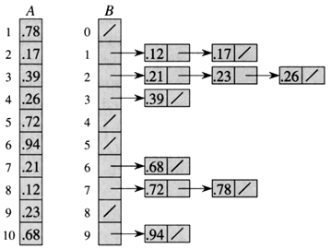
Result and Analysis:
In the above Bucket sort algorithm, we observe in the best case, the algorithm distributes the elements uniformly between buckets, a few elements are placed on each bucket and sorting the buckets is O (1). Rearranging the elements is one more run through the initial list.
T (n) = [time to insert n elements in array A] + [time to go through auxiliary array B [0 . . . n-1] * (Sort by INSERTION_SORT)
= O (n) + (n-1) (n)
= O (n)
In the worst case, the elements are sent all to the same bucket, making the process take O (n^2).

Viva - Questions:
  - Is the bucket sort in place sort? Why or why not?

  - Is bucket sort a stable sort?

  - Why bucket sort is good for large size arrays?

  - State any disadvantage of using this sort.

  - Can this sort be used for sorting negative numbers?

    - Radix sort
Instructions:
Radix Sort is a non-comparative sorting algorithm. It is one of the most efficient and fastest linear sorting algorithms. In radix sort, we first sort the elements based on last digit (least significant digit). Then the result is again sorted by second digit, continue this process for all digits until we reach most significant digit. We use counting sort to sort elements of every digit.
Let A be an array and d be number of digits.
Pseudo code:

Radix-Sort(A, d)
//It works same as counting sort for d number of passes.
//Each key in A [1...n] is a d-digit integer.
// (Digits are numbered 1 to d from right to left.)
for j = 1 to d do
//A[]-- Initial Array to Sort
intcount[10] = {0};
//Store the count of "keys" in count[]
//key- it is number at digit place j
for i = 0 to n do
count[key of(A[i]) in pass j]++

fork = 1 to 10 do
count[k] = count[k] + count[k-1]

//Build the resulting array by checking
//new position of A[i] from count[k]
for i = n-1 down to 0 do
result[ count[key of(A[i])] ] = A[j]
count[key of(A[i])]--

//Now main array A[] contains sorted numbers
//according to current digit place
for i=0 to n do
A[i] = result[i]

end for(j)
end func

Sample Example:
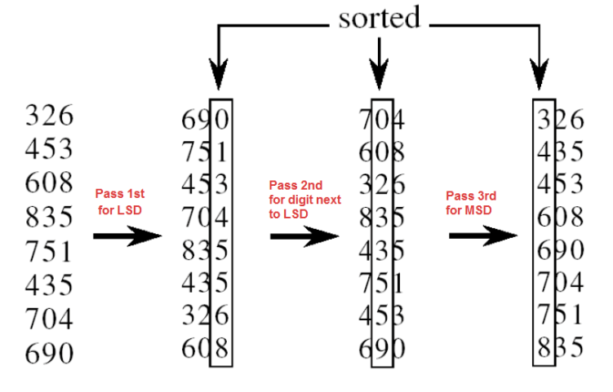
In the above example:
For 1st pass: We sort the array on basis of least significant digit (1s place) using counting sort. Notice that 435 is below 835, because 435 occurred below 835 in the original list.
For 2nd pass: We sort the array on basis of next digit (10s place) using counting sort. Notice that here 608 is below 704, because 608 occurred below 704 in the previous list, and similarly for (835, 435) and (751, 453).
For 3rd pass: We sort the array on basis of most significant digit (100s place) using counting sort. Notice that here 435 is below 453, because 435 occurred below 453 in the previous list, and similarly for (608, 690) and (704, 751).

Result and Analysis:
In this algorithm running time depends on intermediate sorting algorithm which is counting sort. If the range of digits is from 1 to k, then counting sort time complexity is O (n+k). There are d passes i.e. counting sort is called d time, so total time complexity is O (nd+nk) =O (nd). As k=O (n) and d is constant, so radix sort runs in linear time. It performs the same way for best case as well

Viva- Questions:
- Is Radix Sort preferable to Comparison based sorting algorithms like Quick-Sort?

- Is this sort stable?

- How much additional space is taken by this sort?

- State any disadvantage of using this sort.

- How can the performance of this sort be improved?

    - Shell sort
Instructions:
It is a generalized version of insertion sort. It is an in–place comparison sort. It is also known as diminishing increment sort; it is one of the oldest sorting algorithms invented by Donald L. Shell (1959.)This algorithm uses insertion sort on the large interval of elements to sort. Then the interval of sorting keeps on decreasing in a sequence until the interval reaches 1. These intervals are known as gap sequence.
Increment Sequences:

Shell’s original sequence: N/2 , N/4 , …, 1 (repeatedly divide by 2);
Hibbard’s increments: 1, 3, 7, …, 2^{k} – 1 ;
Knuth’s increments: 1, 4, 13, …, (3^{k} – 1) / 2 ;
Sedge wick’s increments: 1, 5, 19, 41, 109…

Here interval is calculated based on Knuth's formula as −
Knuth's Formula
h = h * 3 + 1, where ->h is interval with initial value 1

Pseudo code:
Procedure shellSort ()
A: array of items
/* calculate interval*/
while interval < A. length /3 do:
interval = interval * 3 + 1
end while

while interval > 0 do:
for outer = interval; outer < A. length; outer ++ do:
/* select value to be inserted */
ValueToInsert = A[outer]
inner = outer;
/*shift element towards right*/
while inner > interval -1 &&A [inner - interval] >= valueToInsert do:
A[inner] = A [inner - interval]
inner = inner - interval
end while
/* insert the number at hole position */
A[inner] = valueToInsert
end for
/* calculate interval*/
interval = (interval -1) /3;
end while
end procedure
Sample Example:

An example run of Shell sort with gaps 5, 3 and 1 is shown below.

 | a₁ | a₂ | a₃ | a₄ | a₅ | a₆ | a₇ | a₈ | a₉ | a₁₀ | a₁₁ | a₁₂
Input data | 62 | 83 | 18 | 53 | 07 | 17 | 95 | 86 | 47 | 69 | 25 | 28
After 5-sorting | 17 | 28 | 18 | 47 | 07 | 25 | 83 | 86 | 53 | 69 | 62 | 95
After 3-sorting | 17 | 07 | 18 | 47 | 28 | 25 | 69 | 62 | 53 | 83 | 86 | 95
After 1-sorting | 07 | 17 | 18 | 25 | 28 | 47 | 53 | 62 | 69 | 83 | 86 | 95

The first pass, 5-sorting, performs insertion sort on five separate sub arrays (a₁, a₆, a₁₁ ), (a₂, a₇, a₁₂), (a₃, a₈), (a₄, a₉), (a₅, a₁₀). For instance, it changes the sub array (a₁, a₆, a₁₁) from (62, 17, 25) to (17, 25, 62). The next pass, 3-sorting, performs insertion sort on the three sub arrays (a₁, a₄, a₇, a₁₀), (a₂, a₅, a₈, a₁₁), (a₃, a₆, a₉, a₁₂). The last pass, 1-sorting, is an ordinary insertion sort of the entire array (a₁... a₁₂).

Result and Analysis:

Since in this algorithm insertion sort is applied in the large interval of elements and then interval reduces in a sequence, therefore the running time of Shell sort is heavily dependent on the gap sequence it uses. So in worst case time complexity is O (n²) and in Average Case time complexity depends on gap sequence while in Best Case Time complexity is O(n*log n)

Viva -Questions:

- How can the time complexity of shell sort be improved?

- State any application of shell sort?

- Given the following list of numbers: [5,16,20,12,3,8,9,17,19,7]. What is the content of the list after all swapping is complete for a gap size of 3?

- Is this sort stable and does it takes extra additional space.

    - Selection sort
Instructions:
Selection sort is a simple sorting algorithm. This sorting algorithm is an in-place comparison-based algorithm in which the list is divided into two parts, the sorted part at the left end and the unsorted part at the right end. Initially, the sorted part is empty and the unsorted part is the entire list. The smallest element is selected from the unsorted array and swapped with the leftmost element, and that element becomes a part of the sorted array. This process continues moving unsorted array boundary by one element to the right.
Pseudo code:
Procedure selection sort
list: array of items
n: size of list
for i = 1 to n - 1
/* set current element as minimum*/
min = i
/* check the element to be minimum */
for j = i+1 to n
if list[j] < list [min] then
min = j;
end if
end for
/* swap the minimum element with the current element*/
if indexMin != i then
swap list[min] and list[i]
end if
end for
end procedure:

Sample Example:
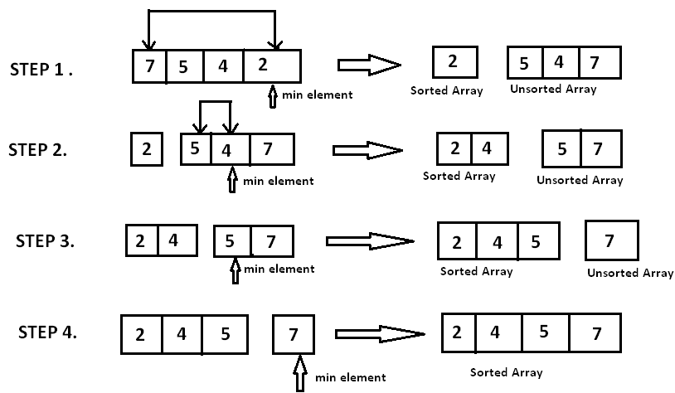

Result and Analysis:

To find the minimum element from the array of N elements, N−1 comparisons are required. After putting the minimum element in its proper position, the size of an unsorted array reduces to N−1 and then N−2 comparisons are required to find the minimum in the unsorted array. Therefore (N−1) + (N−2) + ....... + 1 = (N (N−1))/2 comparisons and N swaps result in the overall complexity of O (N2

Viva - Questions:

- What is the average case performance of Selection Sort?

- For each i from 1 to n-1, how many comparisons are there in this sort?

- If all the input elements are identical then how it will affect the time taken by this sort?

- What is the output of selection sort after the 2nd iteration given the following sequence of numbers: 16 3 46 9 28 14

- What is straight selection sort?

    - Heap sort
Instructions:
This algorithm is divided into two basic parts:
- Creating a Heap of the unsorted list.
- Then a sorted array is created by repeatedly removing the largest/smallest element from the heap, and inserting it into the array. The heap is reconstructed after each removal.

What is a heap?

Heap is a special tree-based data structure, which satisfies the following special heap properties:

Shape Property: Heap data structure is always a Complete Binary Tree, which means all levels of the tree are fully filled.

Heap Property: All nodes are either [greater than or equal to] or [less than or equal to] each of its children. If the parent nodes are greater than their children, heap is called a Max-Heap, and if the parent nodes are smaller than their child nodes, heap is called Min-Heap.

Initially on receiving an unsorted list, the first step in heap sort is to create a Heap data structure (Max-Heap or Min-Heap). Once heap is built, the first element of the Heap is either largest or smallest (depending upon Max-Heap or Min-Heap), so we put the first element of the heap in our array. Then we again make heap using the remaining elements, to again pick the first element of the heap and put it into the array. We keep on doing the same repeatedly until we have the complete sorted list in our array.
Pseudo code:
Heapsort (A) {
BuildHeap(A)
for i <- length (A) downto 2 {
exchange A [1] <-> A[i]
heapsize <- heapsize -1
Heapify(A, 1)
}

BuildHeap (A) {
heapsize <- length (A)
for i <- floor (length/2) downto 1
Heapify (A, i)
}

Heapify (A, i) {
le <- left (i)
ri <- right(i)
if (le<=heapsize) and (A[le]>A[i])
largest <- le
else
largest <- i
if (ri<=heapsize) and (A[ri]>A[largest])
largest <- ri
if (largest != i) {
exchange A[i] <-> A[largest]
Heapify(A, largest)
}
}

Sample Example:
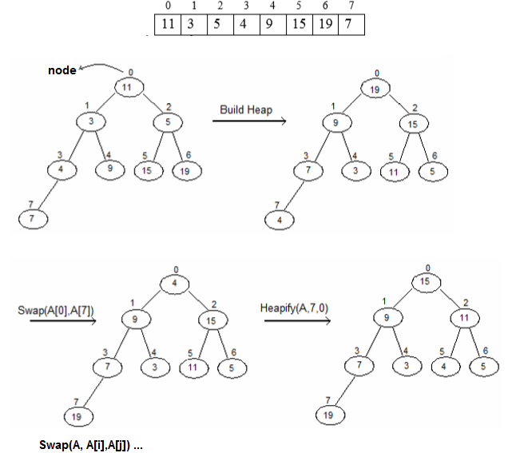
Result and Analysis:
Heap sort has the best possible worst case running time complexity of O (n Log n).It doesn't need any extra storage and that makes it good for situations where array size is large. Heapify runs in time O (h) and there are at most n=2^{h+1}-1 nodes in an almost complete binary tree of height h, so Heapify runs in time O (ln n). Build-Heap calls Heapify n/2 times, so it takes O (n h) = O (n ln n).

Viva - Questions:
- What are the minimum and maximum numbers of elements in a heap of height h?

- Where in a heap might the smallest element reside?

- Is an array that is in reverse sorted order a heap?

- Does heap sort uses extra space for storage?

- What is the effect of calling HEAPIFY (A, i) when the element A[i] is larger than its children?

Experiment 2
Aim: To implement Linear search and Binary search and analyse its time complexity.
Instructions:
The search operation can be done in the following two ways:
Linear search:
It’s a sequential search is made over all items one by one. Every item is checked and if a match is found then that particular item is returned, otherwise the search continues till the end of the data collection.
Binary search:
This search algorithm works on the principle of divide and conquers. For this algorithm, the data collection should be in the sorted form. Binary search looks for a particular item by comparing the middle most item of the collection. If a match occurs, then the index of item is returned. If the middle item is greater than the item, then the item is searched in the sub-array to the left of the middle item. Otherwise, the item is searched for in the sub-array to the right of the middle item. This process continues on the sub-array as well until the size of the sub array reduces to zero.

Pseudo code for linear search:
Procedure linear_search (list, value)
for each item in the list
if match item == value
return the item's location
end if
end for
end procedure

Pseudo code for Binary search:
BinarySearch (A [0...N-1], value)
{
low = 0
high = N - 1
while (low <= high) {
// invariants: value > A[i] for all i < low
value < A[i] for all i > high
mid = (low + high) / 2
if (A[mid] > value)
high = mid - 1
else if (A[mid] < value)
low = mid + 1
else
return mid
}
return not_found // value would be inserted at index "low"
}

Sample Example:
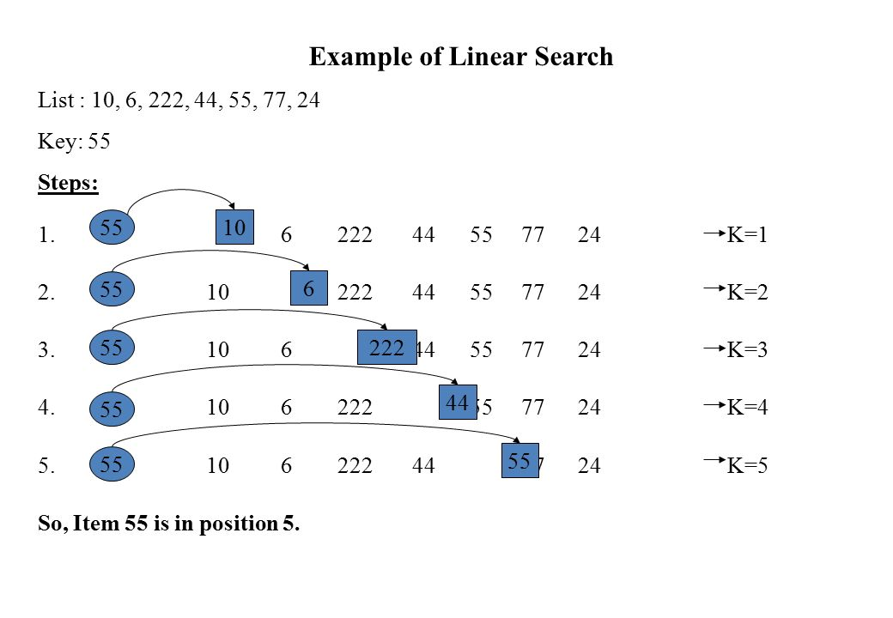
Example of Binary Search:
A sorted array is taken as input. The mid value is found out recursively.

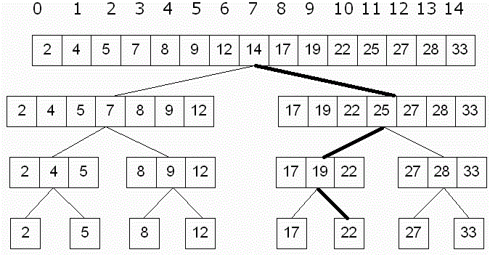

Result and Analysis:
Input data needs to be sorted in Binary Search and not in Linear Search and it does the sequential access whereas Binary search access data randomly. So, time complexity of linear search is O (n) while Binary search has time complexity O (log n) as search is done to either half of the given list.

Viva Questions:
Q1. The sequential search, also known as ___________________

Q2. What is the primary requirement for implementation of binary search in an array?

Q3. Is binary search applicable on array and linked list both?

Q4. What is the principle of working of Binary search?

Q5. Which searching algorithm is efficient one?

Q6. Under what circumstances, binary search cannot be applied to a list of elements?

Experiment 3
Aim: To implement Matrix chain Multiplication and analyse its time complexity.
Problem: Given a sequence of matrices A1, A2… An, insert parentheses so that the product of the matrices, in order, is unambiguous and needs the minimal number of multiplication

Matrix multiplication is associative: A1 (A2A3) = (A1A2) A3

A product is unambiguous if no factor is multiplied on both the left and the right and all factors are either a single matrix or an unambiguous product.
Multiplying an i×j and a j×k matrix requires ijk multiplications. Each element of the product requires j multiplications, and there are ik elements

Number of Parenthesizations
Given the matrices A1,A2,A3, A4. Assume the dimensions of A1=d0×d1, etc. Below are the five possible parenthesizations of these arrays, along with the number of multiplications:
    - (A1A2)(A3A4):d0d1d2+d2d3d4+d0d2d4
    - ((A1A2)A3)A4:d0d1d2+d0d2d3+d0d3d4
    - (A1(A2A3))A4:d1d2d3+d0d1d3+d0d3d4
    - A1((A2A3)A4):d1d2d3+d1d3d4+d0d1d4
    - A1(A2(A3A4)):d2d3d4+d1d2d4+d0d1d4
The number of parenthesizations is at least T(n)≥T(n−1)+T(n−1).Since the number with the first element removed is T(n−1), which is also the number with the last removed. Thus the number of parenthesizations is Ω(2n). The number is actually T (n)=n−1∑k=1T(k)T(n−k) which is related to the Catalan numbers.This is because the original product can be split into 2 sub products in k places. Each split is to be parenthesized optimally.This recurrence is related to the Catalan numbers.

Characterizing the Optimal Parenthesization
An optimal parenthesization of A1…An must break the product into two expressions, each of which is parenthesized or is a single array. Assume the break occurs at position k. In the optimal solution, the solution to the product A1…Ak must be optimal otherwise, we could improve A1…An by improving A1…Ak but the solution to A1…An is known to be optimal.This is a contradiction.Thus the solution to A1…An is known to be optimal.

Principle of Optimality
This problem exhibits the Principle of Optimality. The optimal solution to product A1…An contains the optimal solution to two sub products. Thus we can use Dynamic Programming. Consider a recursive solution
Then improve its performance with memoization or by rewriting bottom up

Matrix Dimensions
Consider matrix product A1×⋯×An. Let the dimensions of matrix Ai be di−1×di.
Thus the dimensions of matrix product Ai×⋯×Aj are di−1×dj.

Recursive Solution
Let M [i,j] represent the number of multiplications required for matrix product Ai×⋯×Aj. For 1≤i≤j<n : M [i,i]=0 since no product is required

The optimal solution of Ai×Aj must break at some point, k, with i≤k<j
Thus, M [i,j]=M[i,k] + M[k+1,j] + di−1dkdj

Thus, M[i,j]={0 if i=j and min i≤k<j{M[i,k]+M[k+1,j]+di−1dkdj}if i<j

Pseudo code:
// Matrix Ai has dimension p[i-1] x p[i] for i = 1..n

MATRIX-CHAIN-ORDER (p)
n←length [p]-1
for i←1 to n
do m[i,i]←0
for l←2to n
do for i←1 to n-l+1
do j←i+l-1
m[i,j]←∞
for k←ito j-1
do q←m[i,k] + m[k+1,j]+p_{i-1}p_{k}p_{j}
if q< m[i,j]
then m[i,j] ←q
s[i,j] ←k
return m and s

PRINT-OPTIMAL-PARENS (s, i, j)
if i=j
then print “A_{i}”
else print “ ( “
PRINT-OPTIMAL-PARENS (s, i, s[i,j])
PRINT-OPTIMAL-PARENS (s, s[i,j]+1, j)
print “ ) ”

Sample Example:

matrix dimension
A₁ 30 x 35
A₂ 35 x 15
A₃ 15 x 5
A₄ 5 x 10
A₅ 10 x 20
A₆ 20 x 25
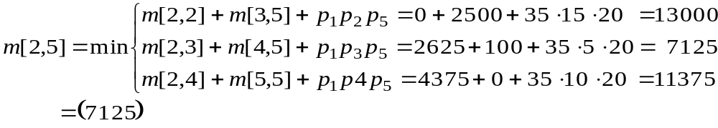
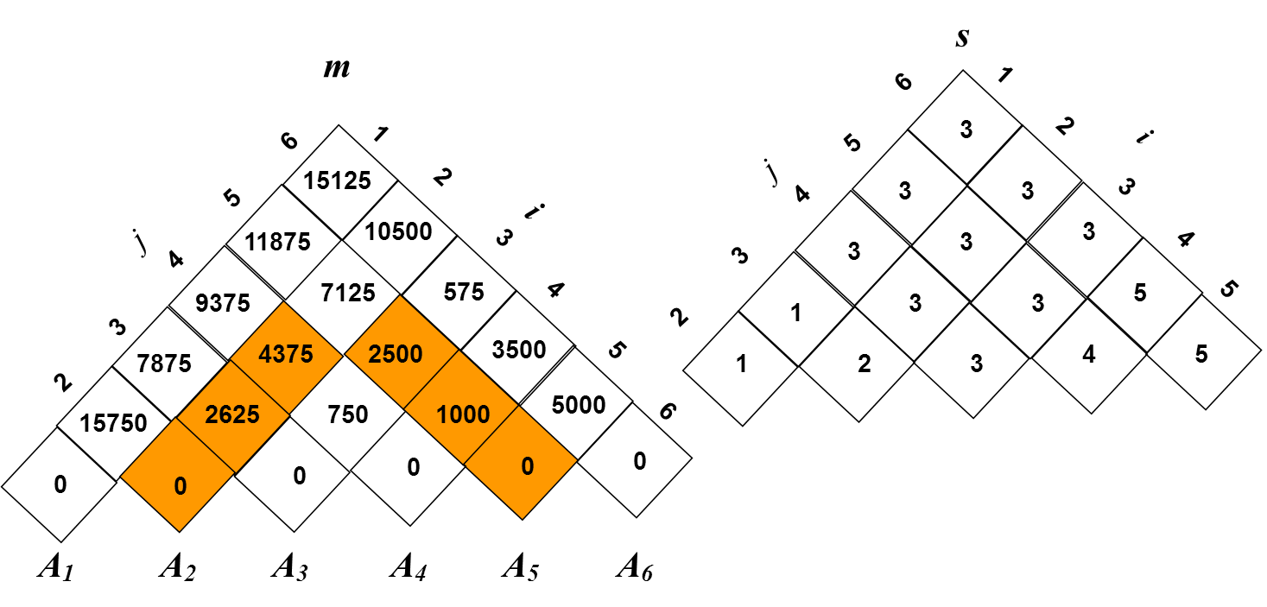

An optimal solution can be constructed from the computed information stored in the table s[1...n, 1...n].The earlier matrix multiplication can be computed recursively.
Result and Analysis:
Clearly, the space complexity of this procedure is Ο (n²). Since the tables m and s require Ο (n²) space. As far as the time complexity is concern, a simple inspection of the for-loop(s) structures gives us a running time of the procedure. Since, the three for-loops are nested three deep, and each one of them iterates at most n times (that is to say indices L, i, and j takes on at most n − 1 values). Therefore, the running time of this procedure is Ο (n³).
Viva- Questions:
- What is the recurrence relation for MCM problem?

- Let A1, A2, A3,A4, A5 be five matrices of dimensions 2x3, 3x5,5x2,2x4,4x3 respectively. Find the minimum number of scalar multiplications required to find the product A1 A2 A3 A4 A5 using the basic matrix multiplication method ?

- Consider the two matrices P and Q which are 10 x 20 and 20 x 30 matrices respectively. What is the number of multiplications required to multiply the two matrices?

- Consider the matrices P, Q and R which are 10 x 20, 20 x 30 and 30 x 40 matrices respectively. What is the minimum number of multiplications required to multiply the three matrices?

- Can this problem be solved by greedy approach. Justify

Experiment 4
Aim: To implement Longest Common Subsequence problem and analyse its time complexity.
Instructions:
The longest common subsequence problem is finding the longest sequence which exists in both the given strings.
Subsequence:
Let us consider a sequence S = <s₁, s₂, s₃, s₄, …,s_{n}>. A sequence Z = <z₁, z₂, z₃, z₄, …,z_{m}> over S is called a subsequence of S, if and only if it can be derived from S deletion of some elements.
Common Subsequence:
Suppose, X and Y are two sequences over a finite set of elements. We can say that Z is a common subsequence of X and Y, if Z is a subsequence of both Xand Y.
Longest Common Subsequence:
If a set of sequences are given, the longest common subsequence problem is to find a common subsequence of all the sequences that is of maximal length. It is a classic computer science problem, the basis of data comparison programs such as the diff-utility, and has applications in bioinformatics.
Naïve Method:
Let X be a sequence of length m and Y a sequence of length n. Check for every subsequence of X whether it is a subsequence of Y, and return the longest common subsequence found. There are 2^{m} subsequences of X. Testing sequences whether or not it is a subsequence of Y takes O(n) time. Thus, the naïve algorithm would take O(n2^{m}) time.
Dynamic Programming:
Let X = < x₁, x₂, x₃,…, x_{m} > and Y = < y₁, y₂, y₃,…, y_{n} > be the sequences. To compute the length of an element the following algorithm is used. In this procedure, table C[m, n] is computed in row major order and another table B[m,n] is computed to construct optimal solution.
Recursive Equation:
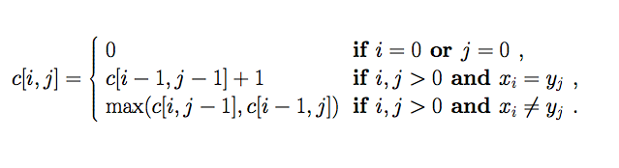
Pseudo code:
Let X and Y are Sequences whose LCS has to be found.
LCS-Length-Table-Formulation (X, Y)
m := length(X)
n := length(Y)
for i = 1 to m do
C [i, 0] := 0
for j = 1 to n do
C [0, j] := 0
for i = 1 to m do
for j = 1 to n do
if x_{i} = y_{j}
C [i, j] := C [i - 1, j - 1] + 1
B [i, j] := ‘D’
else
if C [i -1, j] ≥ C [i, j -1]
C [i, j] := C [i - 1, j] + 1
B [i, j] := ‘U’
else
C [i, j] := C [i, j - 1] + 1
B [i, j] := ‘L’
return C and B

Algorithm: Print-LCS (B, X, i, j)
if i = 0 and j = 0
return
if B[i, j] = ‘D’
Print-LCS(B, X, i-1, j-1)
Print(x_{i})
else if B[i, j] = ‘U’
Print-LCS(B, X, i-1, j)
else
Print-LCS(B, X, i, j-1)

Sample Example:
We have two strings X = BACDB and Y = BDCB to find the longest common subsequence.
Following the algorithm LCS-Length-Table-Formulation (as stated above), we have calculated table C (shown on the left hand side) and table B (shown on the right hand side). In table B, instead of ‘D’, ‘L’ and ‘U’, we are using the diagonal arrow, left arrow and up arrow, respectively. After generating table B, the LCS is determined by function LCS-Print. The result is BCB.
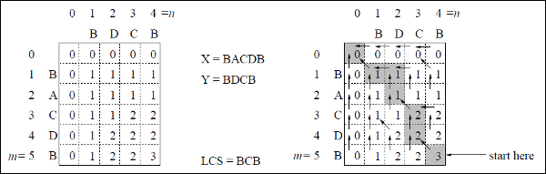
Result and Analysis:
To populate the table, the outer for loop iterates m times and the inner for loop iterates n times. Hence, the complexity of the algorithm is O (m, n), where m and n are the length of two strings.

Viva- Questions:
- Give any application of LCS problem

- Can LCS problem be solved by Greedy strategy

- Find the LCS for input Sequences “ABCDGH” and “AEDFHR”

- Find X= BDCABA and Y= ABCBDAB. Find the length of LCS

Experiment 5
Aim: To implement Optimal Binary Search Tree problem and analyse its time complexity.
Instructions:
In computer science, an optimal binary search tree (OBST), sometimes called a weight-balanced binary tree, is a binary search tree which provides the smallest possible search time for a given sequence of accesses (or access probabilities). Optimal BSTs are generally divided into two types: static and dynamic.
In the static optimality problem, the tree cannot be modified after it has been constructed. In this case, there exists some particular layout of the nodes of the tree which provides the smallest expected search time for the given access probabilities. Various algorithms exist to construct or approximate the statically optimal tree given the information on the access probabilities of the elements.
- OBST is one special kind of advanced tree.
- It focus on how to reduce the cost of the search of the BST.
- It may not have the lowest height !
- It needs 3 tables to record probabilities, cost, and root.
- It has n keys (representation k₁,k₂,…,k_{n}) in sorted order (so that k₁<k₂<…<k_{n}), and we wish to build a binary search tree from these keys. For each k_{i} ,we have a probability p_{i} that a search will be for k_{i}.
- In contrast of, some searches may be for values not in k_{i}, and so we also have n+1 “dummy keys” d₀,d₁,…,d_{n} representing not in k_{i}.
- In particular, d₀ represents all values less than k₁, and d_{n} represents all values greater than k_{n}, and for i=1,2,…,n-1, the dummy key d_{i} represents all values between k_{i} and k_{i+1}.
＊The dummy keys are leaves (external nodes), and the data keys mean internal nodes.
Step1:The structure of an OBST
To characterize the optimal substructure of OBST, we start with an observation about sub trees. Consider any sub tree of a BST. It must contain keys in a contiguous range ki,…,kj, for some 1≦i ≦j ≦n. In addition, a sub tree that contains keys ki,…,kj must also have as its leaves the dummy keys d_{i-1} ,…, d_{j}

- We need to use the optimal substructure to show that we can construct an optimal solution to the problem from optimal solutions to sub problems. Given keys k_{i} ,…, k_{j}, one of these keys, say k_{r} (I ≦r ≦j), will be the root of an optimal sub tree containing these keys. The left sub tree of the root k_{r} will contain the keys (k_{i} ,…, k_{r-1}) and the dummy keys( d_{i-1} ,…, d_{r-1}), and the right sub tree will contain the keys (k_{r+1} ,…, k_{j}) and the dummy keys( d_{r} ,…, d_{j}). As long as we examine all candidate roots k_{r}, whereI ≦r ≦j, and we determine all optimal binary search trees containing k_{i} ,…, k_{r-1} and those containing k_{r+1} ,…, k_{j} , we are guaranteed that we will find an OBST.
- There is one detail worth nothing about “empty” sub trees. Suppose that in a sub tree with keys k_{i},...,k_{j}, we select k_{i} as the root. By the above argument, k_{i} ‘s left sub tree contains the keys k_{i},…, k_{i-1}. It is natural to interpret this sequence as containing no keys. It is easy to know that sub trees also contain dummy keys. The sequence has no actual keys but does contain the single dummy key d_{i-1}. Symmetrically, if we select k_{j} as the root, then k_{j}‘s right sub tree contains the keys, k_{j+1} …,k_{j}; this right sub tree contains no actual keys, but it does contain the dummy key d_{j}.
Step2: A recursive solution
- We need to define the value of an optimal solution recursively. We pick our sub problem domain as finding an OBST containing the keys k_{i},…,k_{j}, where i≧1, j ≦n, and j ≧ i-1. (It is when j=i-1 that there are no actual keys; we have just the dummy key d_{i-1}.)
- Let us define e [i,j] as the expected cost of searching an OBST containing the keys k_{i},…, k_{j}. Ultimately, we wish to compute e[1,n].
- The easy case occurs when j=i-1. Then we have just the dummy key d_{i-1}. The expected search cost is e [i,i-1]= q_{i-1}.
- When j≧1, we need to select a root k_{r} from among k_{i},…,k_{j} and then make an OBST with keys k_{i},…,k_{r-1} its left sub tree and an OBST with keys k_{r+1},…,k_{j} its right sub tree. By the time, what happens to the expected search cost of a sub tree when it becomes a sub tree of a node? The answer is that the depth of each node in the sub tree increases by 1.
- By the second statement, the excepted search cost of this sub tree increases by the sum of all the probabilities in the sub tree. For a sub tree with keys k_{i},…,k_{j} let us denote this sum of probabilities as
w (i , j) = (l=i~j) ∑ p_{l} + (l=i-1~j) ∑ q_{l}
Thus, if k_{r} is the root of an optimal sub tree containing keys k_{i},…,k_{j}, we have
E[i,j]= p_{r} + (e[i,r-1]+w(i,r-1))+(e[r+1,j]+w(r+1,j))
Nothing that w (i , j) = w(i,r-1)+ p_{r} +w(r+1,j)
- We rewrite e[i,j] as
e[i,j]= e[i,r-1] + e[r+1,j]+w(i,j)
The recursive equation as above assumes that we know which node k_{r} to use as the root. We choose the root that gives the lowest expected search cost, giving us our final recursive formulation:
E[i,j]=
case1: if i≦j,i≦r≦j
E[i,j]=min{e[i,r-1]+e[r+1,j]+w(i,j)}
case2: if j=i-1; E[i,j]= q_{i-1}
- The e[i,j] values give the expected search costs in OBST. To help us keep track of the structure of OBST, we define root[i,j], for 1≦i≦j≦n, to be the index r for which k_{r} is the root of an OBST containing keys k_{i},…,k_{j}.
Step3: Computing the expected search cost of an OBST
- We store the e[i.j] values in a table e[1..n+1, 0..n]. The first index needs to run to n+1rather than n because in order to have a sub tree containing only the dummy key d_{n}, we will need to compute and store e[n+1,n]. The second index needs to start from 0 because in order to have a sub tree containing only the dummy key d₀, we will need to compute and store e[1,0]. We will use only the entries e[i,j] for which j≧i-1. we also use a table root[i,j], for recording the root of the sub tree containing keys k_{i},…, k_{j}. This table uses only the entries for which 1≦i≦j≦n.
- We will need one other table for efficiency. Rather than compute the value of w(i,j) from scratch every time we are computing e[i,j] . We keep these values in a table w[1..n+1,0..n]. For the base case, we compute w [i,i-1] = q_{i-1} for 1≦i ≦n.
- For j≧I, we compute :
Ww[i,j]=w[i,j-1]+p_{i+}q_{i}
Pseudo code:
OPTIMAL—BST(p,q,n)
For i 1 to n+1
do e[i,i-1] <- q_{i-1}
do w[i,i-1] <- q_{i-1}
For l 1 to n
do for i <- 1 to n-l +1
do j <- i+l-1
e[i,j] <- ∞
w[i,j] <- w[i,j-1]+p_{j+}q_{j}
For r <- i to j
do t <- e[i,r-1]+e[r+1,j]+w[i,j]
if t<e[i,j]
then e[i,j] <- t
root [i,j] <- r
Return e and root

Sample Example:
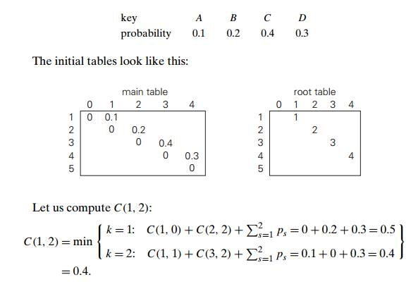
Thus, out of two possible binary trees containing the first two keys, A and B, the root of the optimal tree has index 2 (i.e., it contains B), and the average number of comparisons in a successful search in this tree is 0.4.
We will arrive at the following final tables using the recurrence equations:
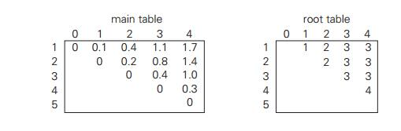
Thus, the average number of key comparisons in the optimal tree is equal to 1.7. Since R(1, 4) = 3, the root of the optimal tree contains the third key, i.e., C. Its left sub tree is made up of keys A and B, and its right sub tree contains just key D. To find the specific structure of these sub trees, we find first their roots by consulting the root table again. Since R(1, 2) = 2, the root of the optimal tree containing A and B is B, with A being its left child (and the root of the one-node tree: R(1, 1) = 1). Since R (4, 4) = 4, the root of this one-node optimal tree is its only key D.

Result and Analysis:
Every time we work on an entry e[i, j] with j − i = k, we know that all the entries e[i 0 , j 0 ] with j 0 − i 0 < k have already been computed. Note that the recursive formula we use to compute e[i, j] only involves entries e[i 0 , j 0 ] with j 0 − i 0 < k. So they are all ready, and we can compute e[i, j] in time O(j − i). It is easy to check that the total running time is Θ (n 3 ).

Viva-Questions:
- What is OBST?

- Give any application of OBST.

- Can OBST be solved using Greedy Approach?

- What is balanced BST?

- What is the best case for OBST?

Experiment 6
Aim: To implement Huffman Coding and analyse its time complexity.

Instructions:
Huffman coding is a lossless data compression algorithm. The idea is to assign variable-length codes to input characters; lengths of the assigned codes are based on the frequencies of corresponding characters. The most frequent character gets the smallest code and the least frequent character gets the largest code.
The variable-length codes assigned to input characters are Prefix Codes means the codes (bit sequences) are assigned in such a way that the code assigned to one character is not prefix of code assigned to any other character. This is how Huffman Coding makes sure that there is no ambiguity when decoding the generated bit stream.
Let us understand prefix codes with a counter example. Let there be four characters a, b, c and d, and their corresponding variable length codes be 00, 01, 0 and 1. This coding leads to ambiguity because code assigned to c is prefix of codes assigned to a and b. If the compressed bit stream is 0001, the de-compressed output may be “cccd” or “ccb” or “acd” or “ab”.

Pseudo code:
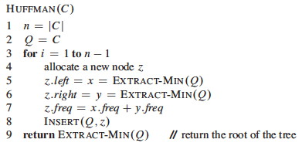

Sample Example:

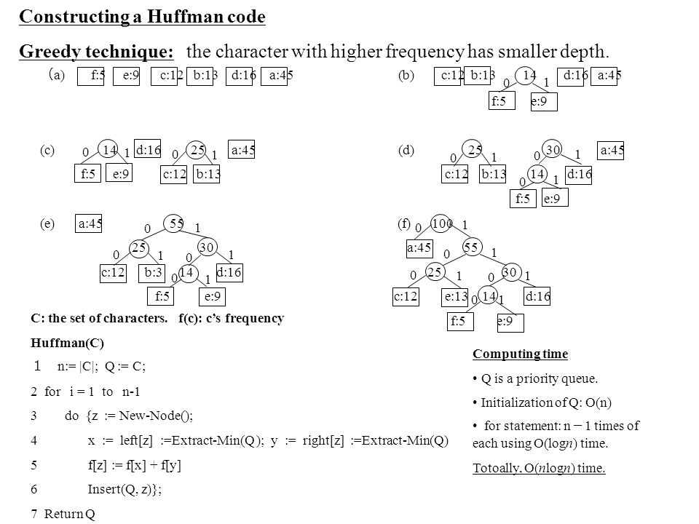

Result and Analysis:
If there are n nodes, extractMin() is called 2*(n – 1) times and extractMin() takes O(log n) time as it calls minHeapify(). So, overall complexity is O (n log n) where n specifies the number of unique characters.

Viva - Questions:

- Why do we use Huffman Codes?

- What happens to the algorithm if the inputs are sorted?

- Which designing technique is used in Huffman coding?

- How many bits may be required for encoding the message ‘mississippi’?

Experiment 7
Aim: To implement Dijkstra’s algorithm and analyse its time complexity.
Instructions:
Dijkstra's algorithm solves the single-source shortest-paths problem on a weighted, directed graph G = (V, E) for the case in which all edge weights are nonnegative. In this section, therefore, we assume that w(u, v) 0 for each edge (u, v) E.
This algorithm maintains a set S of vertices whose final shortest-path weights from the source s have already been determined. That is, for all vertices v S, we have d[v] = (s, v). The algorithm repeatedly selects the vertex u V - S with the minimum shortest-path estimate, inserts u into S, and relaxes all edges leaving u. In the following implementation, we maintain a priority queue Q that contains all the vertices in V - S, keyed by their d values. The implementation assumes that graph G is represented by adjacency lists.
Pseudo code:
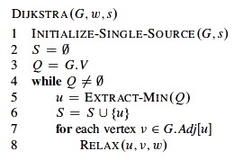
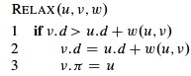

Sample Example:
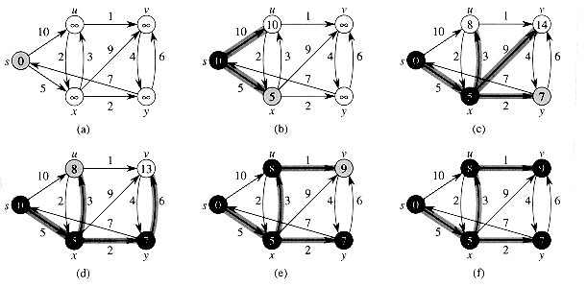
Result and Analysis:
Every time the main loop executes, one vertex is extracted from the queue. Assuming that there are V vertices in the graph, the queue may contain O(V) vertices. Therefore the total run time is O (V lg V + E lg V), which is O(E lg V) because V is O(E) assuming a connected graph.

Viva - Questions:
- Which data structure is used in Dijkstra’s algorithm so that it runs in linear time?

- Can this algorithm work for negative edges? Reason?

- Which algorithm can be used to efficiently calculate single source shortest paths in a Directed Acyclic Graph?

- What are strongly connected components in a graph?

- If weight of every edge is same, then using which algorithm we can efficiently find shortest path from a given source to destination?

- Give any application of this algorithm?

Experiment 8
Aim: To implement Bellman Ford algorithm and analyse its time complexity.
Instructions:
The Bellman-Ford algorithm solves the single-source shortest-paths problem in the more general case in which edge weights can be negative. Given a weighted, directed graph G = (V, E) with source s and weight function w : E R , the Bellman-Ford algorithm returns a Boolean value indicating whether or not there is a negative-weight cycle that is reachable from the source. If there is such a cycle, the algorithm indicates that no solution exists. If there is no such cycle, the algorithm produces the shortest paths and their weights.
Like Dijkstra's algorithm, the Bellman-Ford algorithm uses the technique of relaxation, progressively decreasing an estimate d[v] on the weight of a shortest path from the source s to each vertex v V until it achieves the actual shortest-path weight (s, v). The algorithm returns TRUE if and only if the graph contains no negative-weight cycles that are reachable from the source.
Pseudo code:
BELLMAN-FORD(G,w,s)
1. INITIALIZE-SINGLE-SOURCE(G,s)
2. for i = 1 to |G.V|-1
3. for each edge (u,v) ∈ G.E
4. RELAX(u,v,w)
5. for each edge (u,v) ∈ G.E
6. if v.d > u.d + w(u,v)
7. return FALSE
8. return TRUE

INITIALIZE-SINGLE-SOURCE(G,s)
1. for each vertex v ∈ G.V
2. v.d = ∞
3. v.pi = NIL
4. s.d = 0

RELAX(u,v,w)
1. if v.d > u.d + w(u,v)
2. v.d = u.d + w(u,v)
3. v.pi = u

Sample Example:
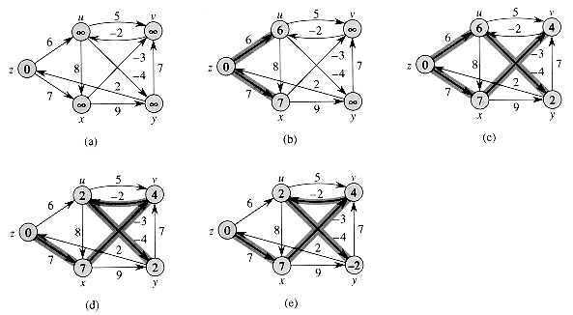
Result and Analysis:
Initialize d's, π's, and set s.d = 0 ⇒ O(V).Loop |V|-1 times through all edges checking the relaxation condition to compute minimum distances ⇒ (|V|-1) O(E) = O(VE). Loop through all edges checking for negative weight cycles which occurs if any of the relaxation conditions fail ⇒ O(E).The run time of the Bellman-Ford algorithm is O(V + VE + E) = O(VE). Note that if the graph is a DAG (and thus is known to not have any cycles), we can make Bellman-Ford more efficient by first topologically sorting G (O(V+E)), performing the same initialization (O(V)), and then simply looping through each vertex u in topological order relaxing only the edges in Adj [u] (O(E)). This method only takes O(V + E) time.

Viva - Questions:
- What is backtracking?

- Given a graph where all edges have positive weights, the shortest paths produced by Dijsktra and Bellman Ford algorithm may be different but path weight would always be same. True or False?

- How this algorithm work for negative weight edges having cycle?

- Give any application of this algorithm?

- Which designing technique is most appropriate for this algorithm?

Experiment 9
Aim: To implement naïve String Matching algorithm, Rabin Karp algorithm and Knuth Morris Pratt algorithm and analyse its time complexity.

      - Naive String Matching Algorithm

Instructions:
The naive string-matching procedure can be interpreted graphically as sliding a "template" containing the pattern over the text, noting for which shifts all of the characters on the template equal the corresponding characters in the text. This algorithm finds all valid shifts using a loop that checks the condition P[1 . . m] = T[s + 1 . . s + m] for each of the n - m + 1 possible values of s, where P is pattern to be found in Text T.

Pseudo code:

NAIVE-STRING-MATCHER(T, P)
1 nlength[T]
2 m length[P]
3 for s 0 ton - m
4 do ifP[1 . . m] = T[s + 1 . . s + m]
then print "Pattern occurs with shift" s

The for loop beginning on line 3 considers each possible shift explicitly. The test on line 4 determines whether the current shift is valid or not; this test involves an implicit loop to check corresponding character positions until all positions match successfully or a mismatch is found. Line 5 prints out each valid shift s.

Sample Example:

The operation of the naive string matcher for the pattern P = aab and the text T = acaabc. We can imagine the pattern P as a "template" that we slide next to the text. Parts (a)-(d) show the four successive alignments tried by the naive string matcher. In each part, vertical lines connect corresponding regions found to match (shown shaded), and a jagged line connects the first mismatched character found, if any. One occurrence of the pattern is found, at shift s = 2, shown in part (c).
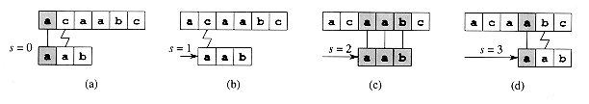

Result and Analysis:
This Procedure takes time ((n - m + 1) m) in the worst case. For each of the n - m + 1 possible values of the shift s, the implicit loop on line 4 to compare corresponding characters must execute m times to validate the shift. The worst-case running time is thus ((n - m + 1) m), which is (n2) if m = n/2 .

Viva- Questions:
- What happens when all characters in the text and pattern are same?

- What happens when only the last character is different?

- When the best case does occurs?

- Give any application of this Algorithm?

- Why is naive approach inefficient?

      - Rabin Karp String Matching Algorithm
Instructions:
Given a pattern P [1 . . m], we let p denote its corresponding decimal value. In a similar manner, given a text T[1 . . n], we let t_{s} denote the decimal value of the length-m substring T[s + 1 . . s + m], for s = 0, 1, . . . , n - m. Certainly, t_{s} = p if and only if T[s + 1 . . s + m] = P[1 . . m]; thus, s is a valid shift if and only if t_{s} = p. If we could compute p in time O(m) and all of the t_{i} values in a total of O(n) time, then we could determine all valid shifts s in time O(n) by comparing p with each of the t_{s}'s.
- We can compute p in time O(m) using Horner's rule :
- p = P[m] + 10 (P[m - 1] + 10(P[m - 2] + . . . + 10(P[2] + 10P[1]) . . . )).
- The value t₀ can be similarly computed from T[1 . . m] in time O(m).
- To compute the remaining values t₁, t₂, . . . , t_{n-m} in time O(n - m), it suffices to observe that t_{s + 1} can be computed from t_{s} in constant time, since
- t_{s} + 1 = 10(t_{s} - 10^{m} - 1T[s + 1]) + T[s + m + 1]. (1)
For example, if m= 5 and t_{s} = 31415, then we wish to remove the high-order digit T[s + 1] = 3 and bring in the new low-order digit (suppose it is T[s + 5 + 1] = 2) to obtain t_{s}+1 = 10(31415 - 10000.3) + 2= 14152 .
Subtracting 10^{m}-1 T[s+1] removes the high-order digit from t_{s}, multiplying the result by 10 shifts the number left one position, and adding T[s + m + 1] brings in the appropriate low-order digit. If the constant 10^{m}-1 is pre computed (which can be done in time O(1g m) , although for this application a straightforward O(m) method is quite adequate), then each execution of equation(1) takes a constant number of arithmetic operations. Thus, p and t₀, t₁, . . , t_{n}-m can all be computed in time O(n + m), and we can find all occurrences of the pattern P[1 . . m] in the text T[1 . . n] in time O(n + m). The only difficulty with this procedure is that p and t_{s} may be too large to work with conveniently. If P contains m characters, then assuming that each arithmetic operation on p (which is m digits long) takes "constant time" is unreasonable. So compute p and the t_{s}'s modulo a suitable modulus q. Since the computation of p, t₀, and the recurrence (1) can all be performed modulo q, we see that p and all the t_{s}'s can be computed modulo q in time O(n + m). The modulus q is typically chosen as a prime such that 10q just fits within one computer word, which allows all of the necessary computations to be performed with single-precision arithmetic.
Pseudo code:
The inputs to the procedure are the text T, the pattern P, the radix d to use (which is typically taken to be ||), and the prime q to use.

RABIN-KARP-MATCHER(T, P, d, q)
1 nlength [T]
2 mlength [P]
3 hd^{m}-1 ^{mod} q
4 p 0
5 t₀ 0
6 for i 1 tom
7 dop (dp + P[i]) mod q
8 t₀ (dt₀ + T[i]) mod q
9 for s 0 ton - m
do if p = t_{s}
11 then if P [1 . . m] = T[s + 1 . . s + m]
12 then "Pattern occurs with shift" s
13 ifs<n - m
14 thent_{s}+1 (d(t_{s} - T[s + 1]h) + T[s + m + 1]) mod q
All characters are interpreted as radix-d digits. The subscripts on t are provided only for clarity; the program works correctly if all the subscripts are dropped. Line 3 initializes h to the value of the high-order digit position of an m-digit window. Lines 4-8 compute p as the value of P[1 . . m] mod q and t₀ as the value of T[1 . . m] mod q. The for loop beginning on line 9 iterates through all possible shifts s. The loop has the following invariant: whenever line 10 is executed, t_{s} = T[s + 1 . . s + m] mod q. If p = t_{s} in line 10 (a "hit"), then we check to see if P[1 . . m] = T[s + 1 . . s + m] in line 11 to rule out the possibility of a spurious hit. Any valid shifts found are printed out on line 12. If s < n - m (checked in line 13), then the for loop is to be executed at least one more time, and so line 14 is first executed to ensure that the loop invariant holds when line 10 is again reached. Line 14 computes the value of t_{s+}1 mod q from the value of t_{s} mod q in constant time.
Sample Example:
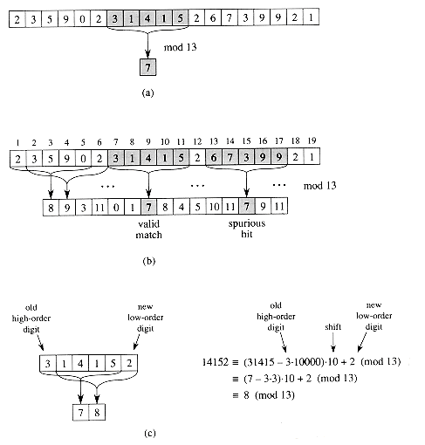

Each character is a decimal digit, and we compute values modulo 13. A text string. A window of length 5 is shown shaded. The numerical value of the shaded number is computed modulo 13, yielding the value 7. The same text string with values computed modulo 13 for each possible position of a length-5 window. Assuming the pattern P = 31415, we look for windows whose value modulo 13 is 7, since 31415 7 (mod 13). Two such windows are found, shown shaded in the figure. The first, beginning at text position 7, is indeed an occurrence of the pattern, while the second, beginning at text position 13, is a spurious hit. The value for a window is computed in constant time, given the value for the previous window. The first window has value 31415. Dropping the high-order digit 3, shifting left (multiplying by 10), and then adding in the low-order digit 2 gives us the new value 14152. All computations are performed modulo 13, however, so the value for the first window is 7, and the value computed for the new window is 8.
In general, with a d-ary alphabet {0, 1, . . . ,d - 1}, we choose q so that d q fits within a computer word and adjust the recurrence equation (1) to work modulo q, so that it becomes
t_{s}+1 = (d(t_{s} - T[s + 1]h) + T[s + m + 1]) mod q ,
where h d^{m}-1 (mod q) is the value of the digit "1" in the high-order position of an m-digit text window.
On the other hand, if (mod q), then we definitely have that t_{s} p, so that shift s is invalid. We can thus use the test t_{s} p (mod q) as a fast heuristic test to rule out invalid shifts s. Any shift s for which t_{s} p (mod q) must be tested further to see if s is really valid or we just have a spurious hit. This testing can be done by explicitly checking the condition P[1 . . m] = T[s + 1 . . s + m]. If q is large enough, then we can hope that spurious hits occur infrequently enough that the cost of the extra checking is low
Result and Analysis:
The running time of this algorithm is ((n - m + 1)m) in the worst case, since (like the naive string-matching algorithm) the Rabin-Karp algorithm explicitly verifies every valid shift. If P = a^{m} and T = a^{n}, then the verifications take time ((n - m + 1)m), since each of the n - m + 1 possible shifts is valid. (Note also that the computation of d^{m}-1 mod q on line 3 and the loop on lines 6-8 take time O(m) = O((n - m + 1 )m).)

Viva- Questions:
- How Rabin Karp can be used to detect plagiarism?

- Give any other application of this algorithm?

- What happens when all characters in the text and pattern are same?

- What is prefix code?

- How Rabin Karp is more efficient than Naive String Matching.

      - Knuth Morris Pratt String Matching Algorithm
Instructions:
At a high level, the KMP algorithm is similar to the naive algorithm: it considers shifts in order from 1 to n−m, and determines if the pattern matches at that shift. The difference is that the KMP algorithm uses information gleaned from partial matches of the pattern and text to skip over shifts that are guaranteed not to result in a match. Suppose that, starting with the pattern aligned underneath the text at the leftmost end, we repeatedly “slide” the pattern to the right and attempt to match it with the text. Let’s look at some examples of how sliding can be done.
Pseudo code:
algorithm KMP(P[1, . . . , m], T[1, . . . , n])
input: pattern P of length m and text T of length n
preconditions: 1 ≤ m ≤ n
output: list of all numbers s, such that P occurs with shift s in T
q ← 0;
i ← 0;
while (i < n) /* P[1, . . . , q] == T[i − q + 1, . . . , i]
{
if (P[q + 1] == T[i + 1])
{
q ← q + 1;
i ← i + 1;
if (q == m)
{
output i − q;
q ← π(q); /*slide the pattern to the right
}
}
else /* a mismatch occurred
{
if (q == 0) { i ← i + 1 }
else { q ← π(q) }
}
}

Sample Example:
T = xyxxyxyxyyxyxyxyyxyxyxxy
And P = xyxyyxyxyxx
Consider the situation when P[1, . . . , 3] is successfully matched with T[1, . . . , 3]. We then find a mismatch: P[4] 6= T[4]. Based on our knowledge that P[1, . . . , 3] = T[1, . . . , 3], and ignoring symbols of the pattern and text after position 3, what can we deduce about where a potential match might be? In this case, the algorithm slides the pattern 2 positions to the right so that P[1] is lined up with T[3]. The next comparison is between P[2] and T[4]. 2. Since P[2] 6= T[4], the pattern slides to the right again, so that the next comparison is between P[1] and T[4]. 3. At a later point, P[1, . . . , 10] is matched with T[6, . . . , 15]. Then a mismatch is discovered: P[11] 6= T[16]. Based on the fact that we know T[6, . . . , 15] = P[1, . . . , 10] (and ignoring symbols of the pattern after position 10 and symbols of the text after position 15), we can tell that the first possible shift that might result in a match is 12. Therefore, we will slide the pattern right, and next ask whether P[1, . . . , 11] = T[13, . . . , 23]. Thus, the next comparisons done are P[4] == T[16], P[5] == T[17], P[6] == T[18] and so on, as long as matches are found.
Sliding rule: We need to make precise exactly how to implement the sliding rule. The following notation is useful. Let S = s1s2 . . . sk be a string. Each string of the form s1 . . . si , 1 ≤ i ≤ k is called a prefix of s. Also, we define the empty string (containing no symbols) to be a prefix of s. A prefix s 0 of s is a proper prefix if s 0 6= s. Similarly, each string of the form si . . . sk, 1 ≤ i ≤ k is called a suffix of s. Also, the empty string (containing no symbols) is a suffix of s. A suffix s 0 of s is a proper suffix if s 0 6= s. Suppose that P[1, . . . , q] is matched with the text T[i−q+1, . . . , i] and a mismatch then occurs: P[q+1] 6= T[i+1]. Then, slide the pattern right so that the longest possible proper prefix of P[1, . . . , q] that is also a suffix of P[1, . . . , q] is now aligned with the text, with the last symbol of this prefix aligned at T[i]. If π(q) is the number such that P[1, . . . , π(q)] is the longest proper prefix that is also a suffix of P[1, . . . , q], then the pattern slides so that P[1, . . . , π(q)] is aligned with T[i − π(q) + 1, . . . , i]. The KMP algorithm pre computes the values π (q) and stores them in a table π[1, . . . , m].
In summary, a “step” of the KMP algorithm makes progress in one of two ways. Before the step, suppose that P [1 . . . q] is already matched with T[i − q + 1, . . . , i]. • If P [q + 1] = T [i+ 1], the length of the match is extended, unless q + 1 = m, in which case we have found a complete match of the pattern in the text. • If P [q + 1] 6= T [i + 1], the pattern slides to the right. In either case, progress is made. The algorithm repeats such steps of progress until the end of the text is reached.
Computing the values π(q): Note that π(1) is always equal to 0. Suppose that we have computed π[1, . . . , i] and we want to compute π(i + 1). Initially we know P[1, . . . , π(i)] is the longest proper prefix of P[1, . . . , i] that is also a suffix of P[1, . . . , i]. Let q = π(i). If P[i + 1] = P[q + 1] then it must be that π(i + 1) = q + 1. Otherwise, we set q = π(q) and repeat the test again. We continue until q = 0, at which point we just set π(i + 1) = 0.
Table of π values for pattern P
P: x y x y y x y x y x x
q: 1 2 3 4 5 6 7 8 9 10 11
π(q): 0 0 1 2 0 3

Result and Analysis:
Each time through the loop, either we increase i or we slide the pattern right. Both of these events can occur at most n times, and so the repeat loop is executed at most 2n times. The cost of each iteration of the repeat loop is O(1). Therefore, the running time is O(n), assuming that the values π(q) are already computed.

Viva - Questions:
- Give any application of KMP algorithm?

- How KMP improves the efficiency?

- When will the best case occur?

- What happens when all the characters in the text and pattern are same?

- What happens when all the characters in the text and pattern are different?

Experiments (Beyond the Syllabus)
- Aim: To implement binomial coefficient computation.
Instructions:
Compared to a brute force recursive algorithm that could run exponential, the dynamic programming algorithm runs typically in quadratic time. The recursive algorithm ran in exponential time while the iterative algorithm ran in linear time. The space cost does increase, which is typically the size of the table. Frequently, the whole table does not have to store.
Computing a Binomial Coefficient
Computing binomial coefficients is non-optimization problem but can be solved using dynamic programming.
Binomial coefficients are represented by C(n, k) or (^{n}_{k}) and can be used to represent the coefficients of a binomial:
(a + b)^{n} = C(n, 0)a^{n} + ... + C(n, k)a^{n-k}b^{k} + ... + C(n, n)b^{n}
The recursive relation is defined by the prior power
C(n, k) = C(n-1, k-1) + C(n-1, k) for n > k > 0
IC C(n, 0) = C(n, n) = 1
Dynamic algorithm constructs a nxk table, with the first column and diagonal filled out using the IC.
Construct the table:

 |  |  |  | k
 |  | 0 | 1 | 2 | ... | k-1 | k
 | 0 | 1
 | 1 | 1 | 1
 | 2 | 1 | 2 | 1
n | .  .  .
 | k | 1 |  |  |  |  | 1
.
.
.
 | n-1 | 1 |  |  |  | C(n-1, k-1)
 | n | 1 |  |  |  |  | C(n, k)

The table is then filled out iteratively, row by row using the recursive relation.

Pseudo code:

Binomial(n, k)
for i ← 0 to n do // fill out the table row wise
for i = 0 to min(i, k) do
if j==0 or j==i then C[i, j] ← 1 // IC
else C[i, j] ← C[i-1, j-1] + C[i-1, j] // recursive relation
return C[n, k]

Sample Example:

Ex: C(3,2) Answer should be 3.
i=0
j= 0 to 0
j=0 :C[0,0]=1
i=1
j= 0 to 1
j=0 :C[2,0]=1
j=1: C[1,1]=1
i=2
j= 0 to 2
j=0 :C[2,0]=1
j=1: C[2,1]=C[1,0]+ C[1,1] =1+1=2
j=1: C[2,1]=1

i=3
j= 0 to 2 (min(i,k) => k=2,i=3)
j=0 : C[3,0]=1
j=1: C[3,1]= C[2,0]+ C[2,1]= 1+2=3
j=2: C[3,2]= C[2,1]+ C[2,2]= 2+1=3
return C[3,2] =>3

Result and Analysis:

The cost of the algorithm is filing out the table. Addition is the basic operation. Because k ≤ n, the sum needs to be split into two parts because only the half the table needs to be filled out for i < k and remaining part of the table is filled out across the entire row.

A(n, k) = sum for upper triangle + sum for the lower rectangle
= ∑_{i=1}^{k} ∑_{j=1}^{i-1} 1 + ∑_{i=1}^{n} ∑_{j=1}^{k} 1
= ∑_{i=1}^{k} (i-1) + ∑_{i=1}^{n} k
= (k-1)k/2 + k(n-k) ε Θ(nk)

Viva - Questions:

- What does dynamic programming have in common with divide and conquer?

- Is it possible to compute C(n,k) by filling the algorithm column by column rather than row by row?

- Can greedy approach also find optimal solution for computing binomial coefficients?

- What are the basic properties of dynamic programming?

- Compute C(6,3) by applying the above dynamic programming Solution?

- Aim: To implement 0-1 Knapsack problem using dynamic programming.
Instructions:
To solve 0-1 Knapsack, Dynamic Programming approach is required as Greedy approach gives an optimal solution for Fractional Knapsack. In 0-1 Knapsack, items cannot be broken which means the thief should take the item as a whole or should leave it. This is reason behind calling it as 0-1 Knapsack. Hence, in case of 0-1 Knapsack, the value of x_{i} can be either 0 or 1

Problem Statement:
A thief is robbing a store and can carry a max_{i}mal weight of W into his knapsack. There are n items and weight of i^{th} item is w_{i} and the profit of selecting this item is p_{i}. What items should the thief take?
Dynamic-Programming Approach:
Let i be the highest-numbered item in an optimal solution S for W dollars. Then S' = S - {i} is an optimal solution for W - w_{i} dollars and the value to the solution S is V_{i} plus the value of the sub-problem. We can express this fact in the following formula: define c[i, w] to be the solution for items 1,2, … , i and the max_{i}mum weight w.
The algorithm takes the following inputs
- The max_{i}mum weight W
- The number of items n
- The two sequences v = <v₁, v₂, …, v_{n}> and w = <w₁, w₂, …, w_{n}>
- Let i be the highest-numbered item in an optimal solution S for W pounds. Then S` = S - {i} is an optimal solution for W - w_{i} pounds and the value to the solution S is V_{i} plus the value of the sub problem.
- We can express this fact in the following formula: define c[i, w] to be the solution for items 1,2, . . . , i and maximum weight w. Then
 |  | 0 |  | if i = 0 or w = 0
c[i,w] = |  | c[i-1, w] |  | if w_{i} ≥ 0
 |  | max [v_{i} + c[i-1, w-w_{i}], c[i-1, w]} |  | if i>0 and w ≥ w_{i}
This says that the value of the solution to i items either include i^{th} item, in which case it is v_{i} plus a sub problem solution for (i - 1) items and the weight excluding w_{i}, or does not include i^{th} item, in which case it is a sub problem's solution for (i - 1) items and the same weight. That is, if the thief picks item i, thief takes v_{i} value, and thief can choose from items w - w_{i}, and get c[i - 1, w - w_{i}] additional value. On other hand, if thief decides not to take item i, thief can choose from item 1,2, . . . , i- 1 upto the weight limit w, and get c[i - 1, w] value. The better of these two choices should be made.
Pseudo code:
The first row of c is filled in from left to right, then the second row, and so on. At the end of the computation, c[n, w] contains the maximum value that can be picked into the knapsack.
Dynamic-0-1-knapsack (v, w, n, W)
for w = 0 to W do
c [0, w] = 0
for i = 1 to n do
c [i, 0] = 0
for w = 1 to W do
if w_{i} ≤ w then
if v_{i} + c[i-1, w-w_{i}] then
c [i, w] = v_{i} + c [i-1, w-w_{i}]
else c [i, w] = c[i-1, w]
else
c [i, w] = c[i-1, w]

The set of items to take can be deduced from the table, starting at c[n, w]and tracing backwards where the optimal values came from. If c [i, w] = c[i-1, w], then item i is not part of the solution, and we continue tracing with c[i-1, w]. Otherwise, item i is part of the solution, and we continue tracing with c[i-1, w-W].
Sample Example:
Assume that we have a knapsack with max weight capacity W = 5
Our objective is to fill the knapsack with items such that the benefit (value or profit) is maximum.
Following table contains the items along with their value and weight.

Item i 1 2 3 4
value val 100 20 60 40
weight wt. 3 2 4 1
Total items n = 4
Total capacity of the knapsack W = 5
Now we create a value table V [i,w] where, i denotes number of items and w denotes the weight of the items. Rows denote the items and columns denote the weight. As there are 4 items so, we have 5 rows from 0 to 4.
And the weight limit of the knapsack is W = 5 so, we have 6 columns from 0 to 5
After calculation, the value table V
V[i,w] | w = 0 | 1 | 2 | 3 | 4 | 5
i = 0 | 0 | 0 | 0 | 0 | 0 | 0
1 | 0 | 0 | 0 | 100 | 100 | 100
2 | 0 | 0 | 20 | 100 | 100 | 120
3 | 0 | 0 | 20 | 100 | 100 | 120
4 | 0 | 40 | 40 | 100 | 140 | 140

Maximum value earned
Max Value = V [n,W]
= V[4,5]
= 140

Result and Analysis:
This algorithm takes θ(n, w) times as table c has (n + 1).(w + 1) entries, where each entry requires θ(1) time to compute.

Viva- Questions:
- Why is the greedy approach not suitable for 0-1 Knapsack Problem

- What is the difference between fractional and 0-1 Knapsack problem

- What is memorization?

- Find out maximum profit for fractional knapsack with maximum allowable weight =14 and n=5
(p1,p2,p3,p4,p5)={70,25,15,29,38};
(w1,w2,w3,w4,w5)={10,1,2,2,6}

- Solve the following instance of the 0/1 knapsack problem using dynamic programming
Weight 1 2 3 2
Profit 10 15 25 12

- Aim: To implement Activity Selection Problem.
Instructions:
The activity selection problem is a mathematical optimization problem that concerning the selection of non-conflicting activities. Each activity assigned by a start time (si) and finish time (fi). The activity selection problem is to select the maximum number of activities that can be performed by a single machine, assuming that a machine can only work on a single activity at a time.
Statement: Given a set S of n activities with and start time, Si and fi, finish time of an ith activity. Find the maximum size set of mutually compatible activities.
Compatible Activities
Activities i and j are compatible if the half-open internal [si, fi) and [sj, fj) do not overlap, that is, i and j are compatible if si ≥ fj and sj ≥ fi
Pseudo code:
Greedy Algorithm for Selection Problem
I. Sort the input activities by increasing finishing time.
f1 ≤ f2 ≤ . . . ≤ fn
II Call GREEDY-ACTIVITY-SELECTOR (Sif)
n = length [s]
A={i}
j = 1
FOR i = 2 to n
do if si ≥ fj
then A= AU{i}
j = i
Return A

Sample Example:
Let 11 activities are given S = {p, q, r, s, t, u, v, w, x, y, z} start and finished times for proposed activities are (1, 4), (3, 5), (0, 6), 5, 7), (3, 8), 5, 9), (6, 10), (8, 11), (8, 12), (2, 13) and (12, 14).
A = {p} Initialization at line 2
A = {p, s} line 6 - 1st iteration of FOR - loop
A = {p, s, w} line 6 -2nd iteration of FOR - loop
A = {p, s, w, z} line 6 - 3rd iteration of FOR-loop
Out of the FOR-loop and Return A = {p, s, w, z}

Result and Analysis:
Part I requires O(nlgn) time (use merge of heap sort).
Part II requires Theta(n) time assuming that activities were already sorted in part I by their finish time.
Viva- Questions:
- Do Dynamic Programming Solution of Activity Selection problem will give optimal Solution?

- The Greedy approach will always give the optimal solution to Activity Selection Problem. Yes or No. And Why?

- Is it necessary to sort the input activities in terms of their finishing times?

- Where can one use Activity Selection Problem?

- Given 10 activities along with their start and finish time as:
A={A1,A2, A3, A4, A5, A6, A7, A8, A9, A10}
S={1, 2, 3, 4, 7, 8, 9,9, 11, 12}
F={3, 5, 4, 7, 10, 9, 11, 13, 12, 14}
Compute a schedule where the largest numbers of activities take place.

- Aim: To implement Kruskal Algorithm.
Instructions:
Spanning Trees: A sub graph of a undirected graph is a spanning tree of a graph if it is a tree and contains every vertex of it.
A Minimum Spanning Tree in an undirected connected weighted graph is a spanning tree of minimum weight (among all spanning trees).
MST Problem: Given a connected weighted undirected graph , design an algorithm that outputs a minimum spanning tree (MST) of G
Kruskal's algorithm is an algorithm in graph theory that finds a minimum spanning tree for a connected weighted graph. This means it finds a subset of the edges that forms a tree that includes every vertex, where the total weight of all the edges in the tree is minimized. If the graph is not connected, then it finds a minimum spanning forest (a minimum spanning tree for each connected component). Kruskal's algorithm is an example of a greedy algorithm
Algorithm Steps:
- create a forest T (a set of trees), where each vertex in the graph is a separate tree
- create a set S containing all the edges in the graph
- while S is nonempty and T is not yet spanning
- remove an edge with minimum weight from S if that edge connects two different trees, then add it to the forest, combining two trees into a single tree, otherwise discard that edge.
At the termination of the algorithm, the forest has only one component and forms a minimum spanning tree of the graph.
Pseudo code:
KRUSKAL(G):
1 A = ∅
2 foreach v ∈ G.V:
3 MAKE-SET(v)
4 foreach (u, v) in G.E ordered by weight(u, v), increasing:
5 if FIND-SET(u) ≠ FIND-SET(v):
6 A = A ∪ {(u, v)}
7 UNION(u, v)
8 return

Sample Example:
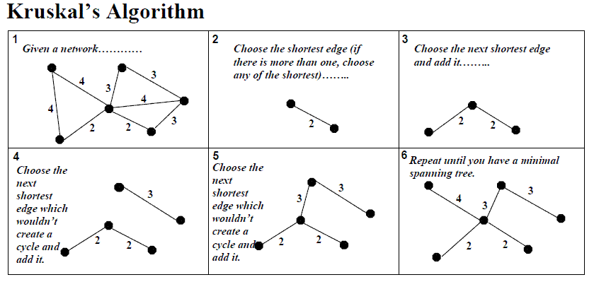

Result and Analysis:
Firstly we want the edges in increasing order by weight. So, just sort the edges, best sorting algorithm with N elements take O(N log N ) time only when we are not using counting sort ( linear time algorithm ) because weight of edges may be high , then its difficult to use hashing as in case of counting sort. So it will take E Log E time , where E = number of edges in the graph => O(E log E ) .If weight are low then we can use linear time sorting algorithm in O(E)
Now, traverse all edges one by one .
Let say current edge is ( U - > V ) , then we have to check whether U and V belong to same component or not , if they are in same component then we have to exclude that edge from our minimum spanning tree , because adding this edge may creat cycle. If Make_set(U) is not equals to Make_set(V) then , it means these nodes are not in the same component, we can add this edge in our spanning tree , and increment our cost with the edge wieght. and then we have to merge both the component , component 1 which contain node U with component 2 with node V then need to find whether which nodes belong to which component and how to merge component.

Total complexity : Sorting time + edge traversel * (Merging operation + find_component_operation )

Viva- Questions:
- Is Kruskal algorithm optimal?

- Give any application of this Algorithm?

- Which designing approach is used for this algorithm?

- How many edges does a minimum spanning tree of n vertices have?

- Why greedy approach is not suitable for Kruskal algorithm?

- Aim: To implement Prims Algorithm.
Instructions:
Start by picking any vertex to be the root of the tree. While the tree does not contain all vertices in the graph find shortest edge leaving the tree and add it to t.
Step 0: Choose any element r; set S={r} and A= empty . (Take r as the root of our spanning tree.)
Step 1: Find a lightest edge such that one endpoint is in S and the other is in V \ S . Add this edge to and its (other) endpoint to S.
Step 2: If V \ S = empty, then stop & output (minimum) spanning tree (S,A) . Otherwise go to Step 1.
The idea: expand the current tree by adding the lightest (shortest) edge leaving it and its endpoint
This algorithm update efficiently by coloring its vertices. Initially all are white. Change the color to black when the vertex is moved to . Use color[v] to store color. The algorithm find the lightest edge and update efficiently by using a priority queue to find the lightest edge and use pred [v ] to update A
Priority Queue is a data structure (can be implemented as a heap) which supports the following operations:
    - insert( u, key ): Insert u with the key value in key in Q.
    - u = extractMin(): Extract the item with the minimum key value in Q.
    - decreaseKey (u,newkey ): Decrease u ’s key value to newkey.
Using a Priority Queue to Find the Lightest Edge:
Each item of the queue is a triple (u, pred[u],key[u]) , where
- u is a vertex in V\S ,
- key[u] is the weight of the lightest edge from u to any vertex in S , and
- pred[u] is the endpoint of this edge in S . The array is used to build the MST

Pseudo code:
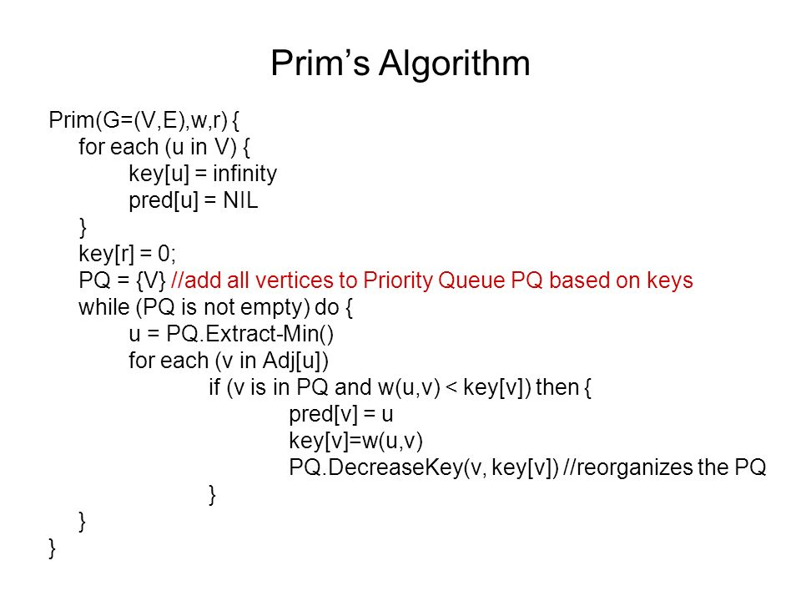
Sample Example:
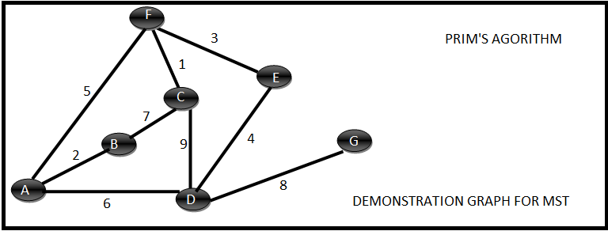
Initialize the priority Queue with all the vertices and assign infinite to each key. Assign zero to A’s key.
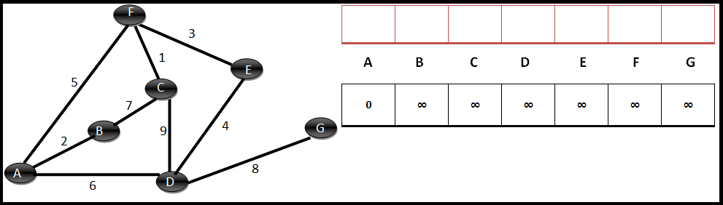

Step 1 :
Extract the minimum (i.e. A) from the Queue and evaluate its adjacent vertices which are still in the queue (B, D, F). For B, 2 is less than its current key (i.e. infinity), so decrease B’s key to 2 and make a note that A is the parent of B. Similarly for D, 6 is less than its current key(i.e. infinity), so decrease D’s key to 6 and make a note that A is the parent of D. Also for F, 5 is less than its current key(i.e. infinity), so decrease F’s key to 5 and make a note that A is parent of D.
Here is the state of the array and the queue after step 1.
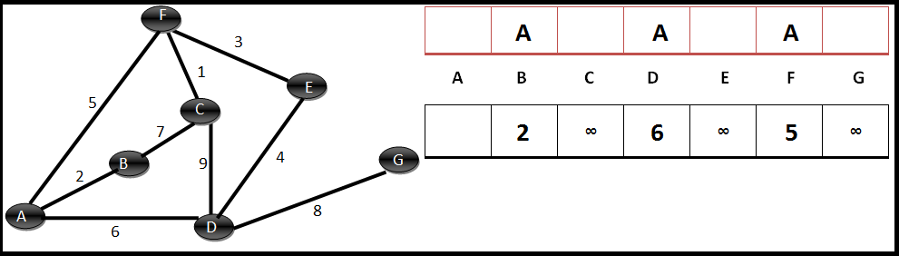
Step 2 :
Extract the minimum (i.e. B) from the Queue and evaluate its adjacent vertices which are still in the queue (C). For c, 7 is less than its current key (i.e. infinity), so decrease C’s key to 7 and make a note that B is the parent of C.
Here is the state of the array and the queue after step 2.
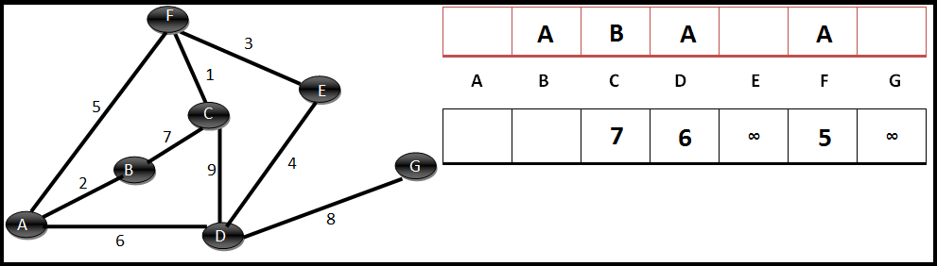
Step 3 :
Extract the minimum (i.e. F) from the Queue and evaluate its adjacent vertices which are still in the queue (C, E). For C, 1 is less than its current key (i.e. 7), so decrease C’s key to 1 and make a note that F is the parent of C. Similarly for E, 3 is less than its current key (i.e. infinity), so decrease E’s key to 3 and make a note that F is the parent of E.
Here is the state of the array and the queue after step 3.
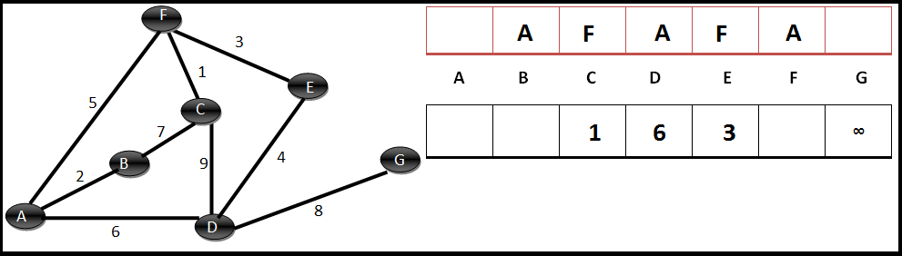
Step 4 :
Extract the minimum (i.e. C) from the Queue and evaluate its adjacent vertices which are still in the queue (D). For D, 9 is greater than its current key (i.e. 6),hence no need to decrease the key or change the state of array.
Here is the state of the array and the queue after step 4.
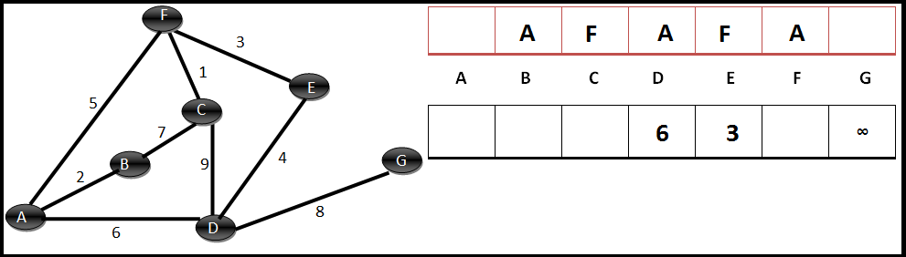
Step 6 :
Extract the minimum (i.e. D) from the Queue and evaluate its adjacent vertices which are still in the queue (G). For G, 8 is less than its current key (i.e. infinity), so decrease G’s key to 8 and make a note that D is the parent of G.
Here is the state of the array and the queue after step 6.
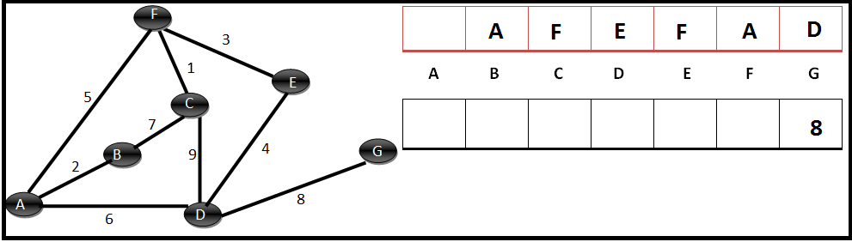
Step 7 :
Extract the minimum (i.e. G) from the Queue and evaluate its adjacent vertices which are still in the queue (None). So the algorithm completes.
The minimum spanning tree can be given by looking at the parent array. It should contain the edges { (A,B), (A,F), (F,C), (F,E), (E,D), (D,G)}.
The minimum spanning tree is shown below:
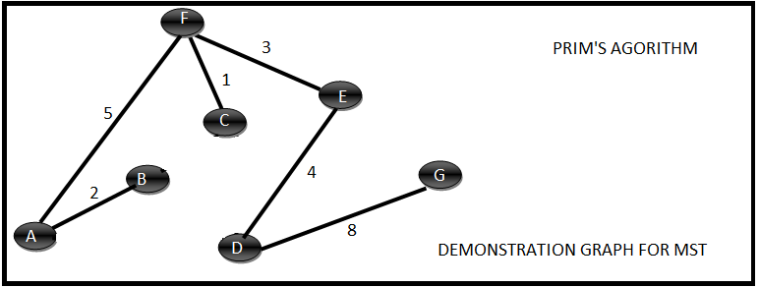

Result and Analysis:
Initialization – The first three lines takes time proportional to the number of vertices O(|V|)
Extract Min – This happens for another |V| times because the size of the queue is |V| at max and in each iteration we invoke the extractMin once.
The For Loop – This happens for k number of times for each vertex where k is the degree of the current vertex. Now considering all the iterations the total degree of all the vertices will the sum of degrees of each vertex and we know that the sum of all the degrees is two times the number of edges or we can say that it is of the order |E|. Hence the if condition is executed a max of O(|E|) times. The if condition is trying to decrease the key of the element in priority queue and this triggers a re-arrangement of elements in the priority queue.

Assume that the time taken to extractMin is T_{ExtractMin} and the time taken to decrease the key is T_{DecreaseKey}. Then the total time taken would be:

T = O(|V| * T_{ExtractMin} + |E| * T_{DecreaseKey})

Viva Questions:
- Can you have cycle in Prim’s Algorithm?

- What is the use of this Algorithm?

- Which designing approach is used to implement Prim’s Algorithm?

- What is a directed acyclic graph?

- Do you get a unique MST always by using Prim’s Algorithm?

- Sample Viva – Questions

- A sorted array is rotated at some unknown point, how to efficiently search an element in it.
- Given a big string of characters, how to efficiently find the first unique character in it?
- How to write an efficient method to calculate x raise to the power n?
- How to find median of a BST?
- Explain the depth of recursion?
- What is the difference between a backtracking algorithm and a brute-force one?
- Describe divide and conquer paradigm.
- What do you mean by Amortized Analysis?
- What are algorithm design techniques?
- What is big (Oh) notation?
- Define order of an algorithm?
- Suppose we have a O(n) time algorithm that finds median of an unsorted array. Now consider a QuickSort implementation where we first find median using the above algorithm, then use median as pivot. What will be the worst case time complexity of this modified QuickSort.
- Given an unsorted array. The array has this property that every element in array is at most k distance from its position in sorted array where k is a positive integer smaller than size of array. Which sorting algorithm can be easily modified for sorting this array and what is the obtainable time complexity?
- What is time complexity of fun()?
int fun(int n)
{
int count = 0;
for (int i = n; i > 0; i /= 2)
for (int j = 0; j < i; j++)
count += 1;
return count;
}
The recurrence relation capturing the optimal time of the Tower of Hanoi problem with n discs is.
- What is the worst case time complexity of insertion sort where position of the data to be inserted is calculated using binary search?
- In a modified merge sort, the input array is splitted at a position one-third of the length (N) of the array. What is the worst case time complexity of this merge sort?
- What is the time complexity of Floyd–Warshall algorithm to calculate all pair shortest path in a graph with n vertices?
- What are the minimum number of comparisons required to find the minimum and the maximum of 100 numbers ?
- You have an array of n elements. Suppose you implement quick sort by always choosing the central element of the array as the pivot. Then what is the tightest upper bound for the worst case performance?
- The characters a to h have the set of frequencies based on the first 8 Fibonacci numbers as follows
a : 1, b : 1, c : 2, d : 3, e : 5, f : 8, g : 13, h : 21
A Huffman code is used to represent the characters. What is the sequence of characters corresponding to the following code? 110111100111010

- Arrange the following functions in increasing asymptotic order:
A. n1/3
B. en
C. n7/4
D. n log9n
E. 1.0000001n
- If we use Radix Sort to sort n integers in the range (n^{k/2},n^{k}], for some k>0 which is independent of n, the time taken would be?
- If one uses straight two-way merge sort algorithm to sort the following elements in ascending order 20, 47, 15, 8, 9, 4, 40, 30, 12, 17 then the order of these elements after the second pass of the algorithm is:
- The minimum number of record movements required to merge five files A (with 10 records), B (with 20 records), C (with 15 records), D (with 5 records) and E (with 25 records) is:
- Consider two strings A = "qpqrr" and B = "pqprqrp". Let x be the length of the longest common subsequence (not necessarily contiguous) between A and B and let y be the number of such longest common sub sequences between A and B. Then x + 10y = ___.
- Let A1, A2, A3, and A4 be four matrices of dimensions 10 x 5, 5 x 20, 20 x 10, and 10 x 5, respectively. The minimum number of scalar multiplications required to find the product A1A2A3A4 using the basic matrix multiplication method is
- Suppose the letters a, b, c, d, e, f have probabilities 1/2, 1/4, 1/8, 1/16, 1/32, 1/32 respectively. What is the Huffman code for the letter a, b, c, d, e, f?
- Consider a situation where you don't have function to calculate power (pow() function in C) and you need to calculate x^n where x can be any number and n is a positive integer. What can be the best possible time complexity of your power function?
- Consider the following recurrence T(n) = 3T(n/5) + lgn * lgn What is the value of T(n)?
- The time complexity of the following C function is (assume n > 0)
int recursive (int n)
{
if (n == 1)
return (1);
else
return (recursive (n-1) + recursive (n-1));
}

